|  |
| --- |
| Blue Talkie: Adding Chat, Walkie-Talkie Capability to Smartphones using Bluetooth |
| COMP-8047 – Major Project |

|  |
| --- |
| Hardavinder Dhaliwal – A00999708  3-16-2024 |

Table of Contents

1. Introduction 3

1.1. Student Background 3

1.1.1. Education 3

1.1.2. Work Experience 3

1.1.3. Projects 3

1.2. Project Description 4

1.2.1. Essential Problems 4

1.2.2. Goals and Objectives 5

2. Body 5

2.1. Background 5

2.2. Project Statement 5

2.3. Possible Alternative Solutions 5

2.4. Chosen Solution 6

2.5. Details of Design and Development 7

2.5.1. Feasibility Assessment Report 7

2.5.2. Use Case Diagram 8

2.5.3. System Architecture Diagram 9

2.5.4. System Component Diagram 11

2.5.5. Class Diagrams 12

2.5.6. BluetalkServer Communication Strategy: Message Protocol, Proxy Discovery, and Secure Forwarding 16

2.5.7. Design Choices 21

2.5.8. User Guide 23

2.6. Testing Details and Results 38

2.6.1. Database Testing 38

2.6.2. UI Testing 39

2.6.3. Acceptance Testing 41

2.7. Implications of Implementation 64

2.7.1. BLE Constraints and Challenges 64

2.7.2. Managing Sequential BLE Operations and Implementing a Queue System 65

2.8. Innovation 66

2.9. Complexity 66

2.10. Research in New Technologies 67

Exploring BLE Technology 67

Limitations and Innovations 67

Bugs, Challenges, and New Applications 68

2.11. Future Enhancements 68

Hybrid Bluetooth System Integration 69

Background Operation Enhancement 69

Connection Reliability and Speed 69

User Interface and Experience 69

Cross-Platform Compatibility 69

2.12. Timeline and Milestones 69

3. Conclusion 70

3.1. Lessons Learned 70

3.2. Closing Remarks 70

4. Appendix 70

4.1. Approved Proposal 70

4.2. Project Supervisor Approvals 70

5. References 71

6. Change Log 71

# Introduction

## Student Background

Driven by a passion for coding, I moved to Canada with little prior programming experience. Eight years ago, I began a diploma in computer science but had to put my education on hold due to personal reasons. Now, as a permanent resident, I have reignited my pursuit of education by working toward a bachelor's degree.

My interests are deeply rooted in networking, especially Bluetooth technology. This fascination has guided my academic journey, allowing me to delve into and understand the intricacies of wireless communications. As I progress, I plan to combine this theoretical knowledge with practical experience, gearing up for a career centered around network technology.

## Education

* Associate Degree of Science in Computer Sciences
  + *Graduated in May 2017*
* *BSc In Applied Computer Science – Networking and Application Development* 
  + *September 2022 - Current*

## Work Experience

* **KFC/TACO BELL, Surrey, BC** *Manager* 2016-Present

### Projects

**2D Chess Game** *Software Developer*

* Engineered a user-interactive 2D Chess game in Java, employing advanced OOP techniques for robust gameplay mechanics.

**3D Room Construction** *Team Collaborator*

* Collaborated on designing a fully textured 3D room using Blender, focusing on realistic light interactions and material textures.

**Animated Web Content** *Graphic Designer & Web Integrator*

* Created and integrated animated graphics into a web-based platform using Adobe Flash and Photoshop, enhancing user engagement through visually appealing elements.

**Digital Clock Circuitry** *Electronic Hobbyist*

* Designed and assembled a digital clock from scratch using IC chips and logic gates, a project that bridged computer science and electronic engineering concepts.

## Acknowledgements

I am deeply grateful to my supervisor, Aman, for his invaluable support and for keeping the faith in BlueTalkie’s vision alive, especially when the proxy feature was at risk due to BLE constraints. His support was crucial in turning those challenges into achievements.

## Project Description

"BlueTalkie" is a pioneering Android application that facilitates seamless offline communication using Bluetooth technology. Apart from text messaging, the application encompasses a Walkie-Talkie feature enabling real-time voice communication. Leveraging existing Bluetooth protocols as its foundation, "Blue Talkie" will introduce innovative extensions and features to cater to unique communication challenges. The app aims to interlink devices in proximity and utilize them as proxies, extending the coverage area. This will also help create Bluetooth mesh networking, which can help send SOS to all devices in emergencies.

The app ensures optimal data integrity and end-to-end encryption by constructing custom protocol extensions and establishing a secure communication channel.

### Essential Problems

BlueTalkie addresses the challenge of maintaining communication amidst losing connectivity due to natural disasters or other unforeseen events. In such instances, traditional communication networks may fail, leaving users incommunicado. By harnessing the capabilities of BLE (Bluetooth Low Energy), BlueTalkie offers a robust alternative. Because Bluetooth technology inherently has a limited range, BlueTalkie creatively expands this range by utilizing a proxy mechanism. This innovative approach enables messages to traverse beyond typical Bluetooth boundaries. To illustrate, consider the following scenario:

|  |  |
| --- | --- |
| A diagram of a cell phone  Description automatically generated  Figure 1-Bluetooth range extension using Device B as a relay | In this scenario, A wants to send a message to D, but D is out of range of A.  However, with the help of a proxy mechanism, device A can send a message to device B, which is within its range. Then, device B, acting as a proxy or relay, can forward the message to device D, which is out of range for device A but within range for device B. This way, the messages can successfully be transferred from A to D even though they are not directly within each other’s Bluetooth range.   In case of an emergency, A can also broadcast the SOS signal to B and C, and then B can send the SOS to D. If C is connected to any device using Blue Talkie, then it can also send an SOS message to them. |

### Goals and Objectives

The goal of BlueTalkie is to provide a reliable way for people to communicate when they don't have access to the internet or cell service. The following are some of the goals:

* To create a reliable and efficient offline communication medium using Bluetooth technology that can function effectively in remote areas, crowded events, natural disasters, and environments with weak internet connectivity.
* To extend the communication range of Bluetooth by implementing a proxy mechanism that allows devices to relay messages, effectively forming a mesh network.
* To integrate a Walkie-Talkie feature that allows real-time voice communication between users within the Bluetooth network.
* To ensure the privacy and security of users through end-to-end encryption of messages.

# Body

## Background

Communication is the backbone of our interconnected society. With the proliferation of smartphones and messaging apps, we expect constant connectivity. However, numerous situations remain in which this connectivity breaks down. Remote areas might lack internet infrastructure, while crowded events can overwhelm cellular and Wi-Fi networks. Furthermore, natural disasters or emergencies can disrupt even the most robust communication networks. Blue Talkie solves this problem by providing chat and real-time voice communication without needing Wi-Fi or an internet connection. By using the proxy mechanism, this app can also send broadcast messages to all the connected devices, and then those devices can send broadcast messages to their connected devices, and so on. This can genuinely help during emergencies when there is no other way to alert others, for example, when the network is down.

## Project Statement

BlueTalkie is designed to revolutionize offline communication by leveraging Bluetooth technology to enable message and voice transmission in the absence of internet or cellular networks. This Android application extends Bluetooth's reach through a proxy mechanism, creating a resilient mesh network essential for emergencies. With an integrated Walkie-Talkie feature and a commitment to robust end-to-end encryption, BlueTalkie prioritizes functionality and security, ensuring reliable and private communication in challenging environments.

## Possible Alternative Solutions

In addressing the challenge of ensuring communication in environments lacking conventional connectivity, several alternative solutions can be considered alongside the BlueTalkie project. Each alternative comes with its own set of benefits and limitations. Here’s a summary of potential alternatives:

1. **Direct Wi-Fi Communication:**
   1. **Description:** Utilizes Wi-Fi Direct technology to enable device-to-device communication without needing a Wi-Fi network.
   2. **Benefits:** Higher data transfer speeds and more extended range than Bluetooth.
   3. **Limitations:** Not all devices support Wi-Fi Direct, and it consumes more power, which may not be ideal for emergencies.
2. **Mesh Networking Devices:**
   1. **Description:** Requires additional hardware to create a mesh network that can relay messages across devices over longer distances.
   2. **Benefits:** Can cover large areas and work in highly remote locations.
   3. **Limitations:** Involves additional cost for purchasing hardware, and users must carry extra devices.
3. **Satellite Messengers:**
   1. **Description:** Uses satellite technology to send messages and SOS alerts from virtually anywhere in the world.
   2. **Benefits:** Global coverage and highly reliable in emergencies.
   3. **Limitations:** High cost for devices and subscription services, and generally limited to text messaging.
4. **Peer-to-Peer (P2P) Radio:**
   1. **Description:** Utilizes walkie-talkies or similar radio devices for direct voice communication over short to medium distances.
   2. **Benefits:** It does not require a network, is simple to use, and is effective in many outdoor environments.
   3. **Limitations:** It necessitates carrying an additional device specifically for peer-to-peer communication, which may not be convenient for all users.

## Chosen Solution

The chosen solution for facilitating communication in areas without internet or cellular connectivity is developing the BlueTalkie application, utilizing Bluetooth Low Energy (BLE) technology. This approach was selected for its numerous advantages, which align closely with the project's objectives of providing a reliable, secure, and accessible communication method. The rationale behind opting for BLE includes:

1. **Widespread Availability:** Smartphones equipped with Bluetooth technology are ubiquitous, meaning that a vast majority of potential users already possess the necessary hardware to use BlueTalkie. This eliminates the need for additional investments in specialized equipment, making it a cost-effective solution.
2. **No Additional Equipment Required:** BlueTalkie leverages the user's existing smartphone, unlike other communication alternatives requiring extra devices. This simplifies usage and ensures users are more likely to adopt and utilize the application in everyday scenarios and emergencies.
3. **Efficient Power Consumption:** BLE is designed for minimal energy use, which is crucial for maintaining device battery life, especially when power sources are scarce. This ensures that users can stay connected for longer periods without worrying about frequent recharging.

The decision to develop BlueTalkie with BLE at its core is driven by the technology's alignment with the project's goal to offer a universally accessible, efficient, and secure platform for offline communication. By capitalizing on the prevalent, built-in capabilities of modern smartphones, BlueTalkie stands as a practical solution for overcoming the challenges posed by the lack of traditional connectivity.

## Details of Design and Development

### Feasibility Assessment Report

In a landscape filled with various communication applications, the market still presents gaps that BlueTalkie aims to fill, capitalizing on the unique features and functionalities that set it apart from existing solutions. The primary differentiators include:

* **No Internet Requirement:** Unlike many applications that rely on Internet connectivity (e.g., WhatsApp, Facebook Messenger), BlueTalkie operates using Bluetooth technology, enabling users to communicate in areas with limited or no Internet access.
* **Privacy and Security:** BlueTalkie strongly emphasizes user privacy. Implementing end-to-end encryption and storing messages directly on devices ensures that users' conversations remain secure and private, contrasting with services that may store data on external servers.
* **Mesh Network Capability:** Through the innovative use of a proxy mechanism, BlueTalkie extends the effective communication range of Bluetooth, allowing messages to be relayed across multiple devices. This feature is not commonly found in similar apps, providing a distinct advantage in scenarios like outdoor activities, festivals, or emergencies where traditional networks are overwhelmed or unavailable.
* **Multiple Device Connectivity:** BlueTalkie supports connecting multiple client applications to a single server simultaneously, enhancing its utility for group communications seamlessly. This multi-device support offers flexibility and convenience, ensuring users remain connected across various devices.

### Use Case Diagram

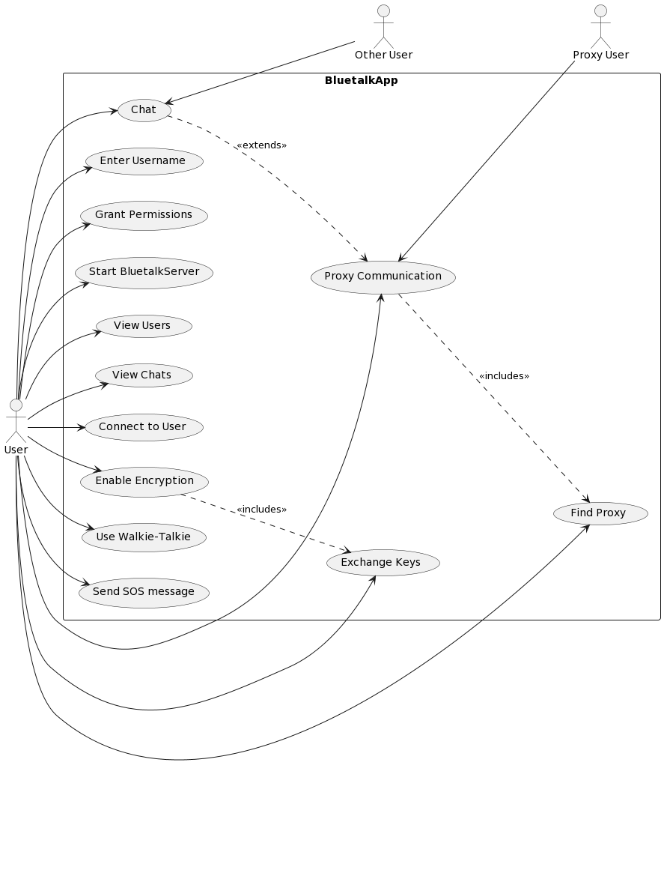

Figure 2 Use Case Diagram

The use case diagram for the BlueTalkie app captures the comprehensive interaction between the user, other users, and proxy users within the app's ecosystem. Initially, the user enters a username and grants necessary permissions, which triggers the startup of BluetalkServer. Users can then either view active nearby users or existing chats. To initiate a chat, a user connects to another user, with an option to enable end-to-end encryption for secure communication; this involves key exchange if encryption is enabled. Users can chat directly or, in case of disconnection, opt for proxy communication to maintain the chat through an available intermediary user, which also prompts a decision on encryption. Additionally, the app offers a walkie-talkie feature, allowing users to send and receive voice notes once connected. This diagram effectively outlines the app's functional flow from startup to direct or proxy communication, emphasizing security through optional encryption and the innovative use of a walkie-talkie feature for voice communication.

### System Architecture Diagram

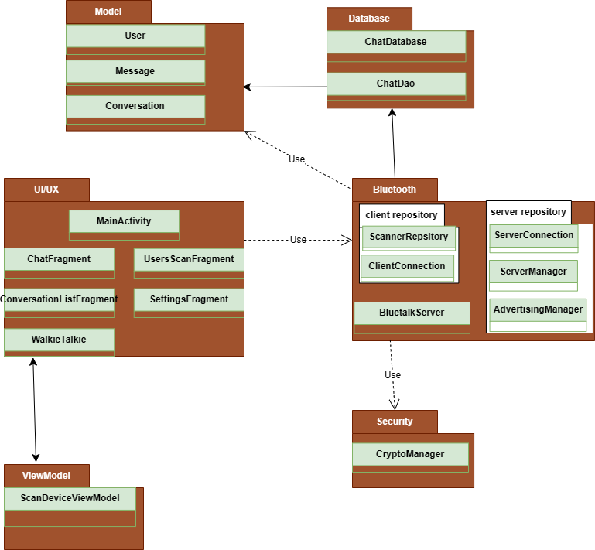

Figure 3 System Architecture Diagram

This diagram provides a structured overview of the BlueTalkie application's architecture. It showcases the logical separation into different layers and packages and illustrates how the various components of the app are organized and interact with each other.

1. **Model Layer**: This layer consists of the fundamental data structures used throughout the application, including **User**, **Message**, and **Conversation** classes. They represent the core business logic and data entities upon which the application operates.
2. **Database Layer**: This layer, which comprises ChatDatabase and ChatDao, is responsible for data persistence, allowing the application to store, retrieve, and manipulate chat data consistently and reliably.
3. **Bluetooth Layer**: This layer handles all Bluetooth operations within the app. It is divided into **client_repository** and **server_repository** for managing client-server communication, including the **BluetalkServer** for centralized control and **AdvertisingManager** for broadcasting device presence.
4. **UI/UX Layer**: Containing classes like **MainActivity**, **ChatFragment**, and **UsersScanFragment**, the UI/UX layer is where user interactions take place. It defines the application's visual elements and is responsible for presenting data to the user and capturing user inputs.
5. **ViewModel Layer**: At this layer, the **ScanDeviceViewModel** class serves as an intermediary between the UI/UX layer and the lower layers. It manages UI-related data and handles the application's response to user interactions.
6. **Security Layer**: The **CryptoManager** class in the security layer provides encryption and decryption functionalities, ensuring secure data exchange throughout the application, particularly within Bluetooth communications.

### System Component Diagram

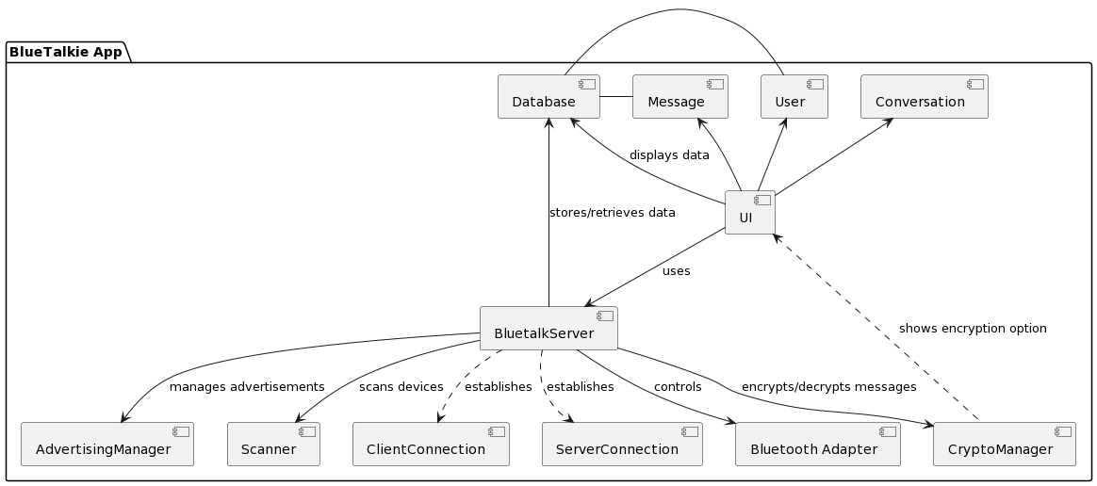

Figure 4 System Component Diagram

**BlueTalkie App Components:**

* **UI (User Interface)**: This component is responsible for all user interactions with the app. It displays information to the user, collects user inputs, and presents data retrieved from the database, such as user lists, chat conversations, and encryption options.
* **BluetalkServer**: This is the core component that manages the app's logic and functionalities. It handles user connections, message sending and receiving, Bluetooth device scanning, and initiating secure communication protocols. It is the intermediary between the UI, Bluetooth Adapter, Database, CryptoManager, and device connections.
* **Bluetooth Adapter**: Manages Bluetooth operations, including scanning for nearby devices and establishing Bluetooth connections. It is controlled by the BluetalkServer to facilitate communication between users.
* **AdvertisingManager**: This handles the device's advertising over Bluetooth to make it discoverable by other users. BluetalkServer utilizes it to manage advertisement settings and operations.
* **Database**: Stores and retrieves data for the application, including user information (User), messages (Message), and conversation records (Conversation). It serves as the persistent storage solution for the app, ensuring that user data and message history are maintained across sessions.
* **CryptoManager**: Manages the encryption and decryption of messages to ensure secure communication between users. This component offers end-to-end encryption options, which users can enable through the UI for privacy-enhanced messaging.
* **Scanner**: A specialized component used by the BluetalkServer to scan for nearby Bluetooth devices. It facilitates the discovery of other users within proximity, enabling connections and communication.
* **ClientConnection & ServerConnection**: Represent the connection instances established with other devices. The BluetalkServer manages these connections, which are essential for direct user-to-user communication and data exchange.
* **User**: A model class representing a user of the app. It includes attributes like the user's name, device information, and other relevant details used within the app.
* **Message**: This is a model class for messages sent and received within the app. It captures the content of messages, sender and receiver information, timestamps, and other metadata necessary for messaging functionality.
* **Conversation**: Represents a conversation between users. This model includes data related to the conversation participants, message history, and any other relevant context for maintaining chat sessions.

### Class Diagrams

#### Bluetooth Layer Class Diagram

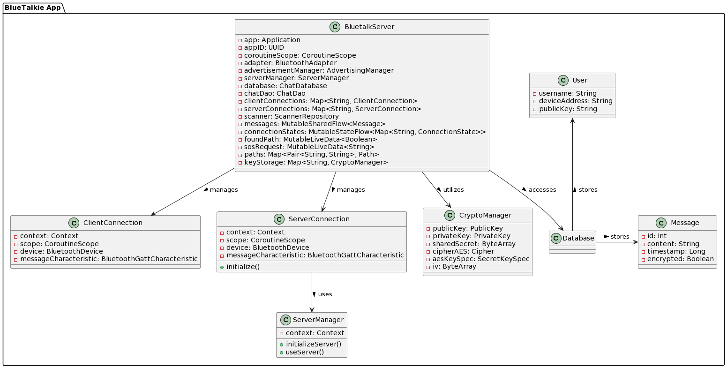

Figure 5 Class Diagram of Bluetooth Layer

**BluetalkServer**

* **Purpose**: Acts as the nerve center of the application's Bluetooth services. It orchestrates the setup and management of Bluetooth connections, handles the logic for sending and receiving messages, and manages the application's state regarding Bluetooth operations. It interfaces with the database for message persistence and utilizes the **CryptoManager** to apply encryption protocols for secure data transmission.

**ClientConnection**

* **Purpose**: This class manages the Bluetooth LE client role within the application. It's responsible for establishing and maintaining connections with other Bluetooth devices, facilitating data transmission, and ensuring that messages are sent and received correctly over the established Bluetooth connection. The class interacts with Bluetooth characteristics and handles communication protocols.

**ServerConnection**

* **Purpose**: This handles the Bluetooth LE server-side connectivity. It's designed to listen for and accept connections from other Bluetooth devices, manage Bluetooth service characteristics, and provide the means for other devices to interact with the app in a server role, enabling bidirectional communication.

**ServerManager**

* **Purpose**: Controls the Bluetooth GATT server infrastructure. This class sets up the Bluetooth services and characteristics that define how the app communicates with other Bluetooth devices in a server capacity.

**CryptoManager**

* **Purpose**: Implements the cryptographic functions required for secure communication within the app. This includes generating key pairs, managing key exchanges to establish a shared secret, and providing encryption and decryption services to safeguard messages against eavesdropping.

#### Database Layer Class Diagram

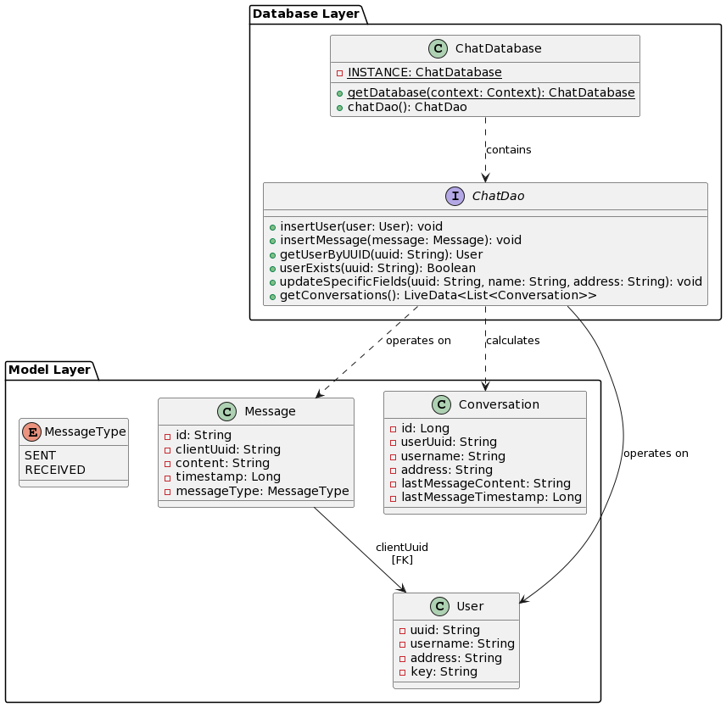

Figure 6 Class Diagram of Database and Models

##### Database Layer

###### ChatDatabase

* **Purpose**: Serves as the app's database class. It is annotated with **@Database**, marking it as a Room database for storing **User** and **Message** entities.
* **Key Features**:
* Singleton pattern ensures a single database instance throughout the app to avoid unnecessary reinitializations.
* Provides a method to access ChatDao to perform database operations.

###### ChatDao

* **Purpose**: Defined as a Data Access Object (DAO) interface. It abstracts the database operations related to **User**, **Message**, and **Conversation** entities.
* **Key Operations**:
  + Insertion methods for **User** and **Message** entities, ensuring data persistence.
  + Query methods for retrieving users, messages, and aggregated conversation data, facilitating data display and manipulation in the UI.
  + Update methods for modifying user details like username and address.

##### Model Layer

###### User

* **Purpose**: Represents the user entity within the app, containing user-specific information.
* **Attributes**:
  + - * 1. **uuid**: A unique identifier for the user.
        2. **username**: The user's chosen username.
        3. **address**: The Bluetooth address of the user's device.
        4. **key**: An optional field that could be used to store encryption keys or related information.

###### Message

* **Purpose**: Models the messages sent and received in the app.
* **Attributes**:
  + - * + **id**: A unique identifier for the message, typically a UUID string.
        + **clientUuid**: The UUID of the user associated with the message.
        + **content**: The textual content of the message.
        + **timestamp**: A timestamp indicating when the message was sent or received.
        + **messageType**: Enum indicating whether the message was sent or received.

### BluetalkServer Communication Strategy: Message Protocol, Proxy Discovery, and Secure Forwarding

#### Message Protocol Components

Each message sent within the BlueTalkie app includes a header with seven components, structured to facilitate various communication needs, including direct messaging, routing requests, and encryption. The components are:

|  |  |  |  |  |  |  |
| --- | --- | --- | --- | --- | --- | --- |
| **Message Type** | **Source UUID** | **Dest UUID** | **Message UUID** | **Source Username** | **Encryption Flag** | **Key Exchange Flag** |

* **Message Type**: Distinguishes the message's purpose, with types including:
  + **0**: Regular one-to-one messages.
  + **1**: Route request (RREQ) for finding a path to a destination.
  + **2**: Route reply (RREP) in response to RREQ, indicating a path has been found.
  + **3**: Forward message, used for proxy communication.
* **Source UUID (srcID)**: The UUID of the message sender.
* **Destination UUID (dstID)**: The UUID of the intended recipient.
* **Message UUID**: A unique identifier for each message to prevent processing duplicates, essential for routing requests.
* **Source Username**: The sender's username, used to create or update user entries without key constraint issues in the database.
* **Encryption Flag**: Indicates whether the message is encrypted (**1**) or not (**0**).
* **Key Exchange Flag**: Specifies if the message contains vital exchange information (**1**) or not (**0**), crucial for initiating or responding to encryption requests.

#### Process of Finding Proxies and Forwarding Messages

1. **Broadcasting Route Requests (RREQ)**:
   * When a user loses a direct connection and agrees to use a proxy, **broadcastMessage()** is invoked with a message type of **1** (RREQ).
   * This function scans for nearby devices. Upon finding devices, it attempts to connect and rebroadcasts the RREQ or responds with an RREP if it matches the **dstID**.

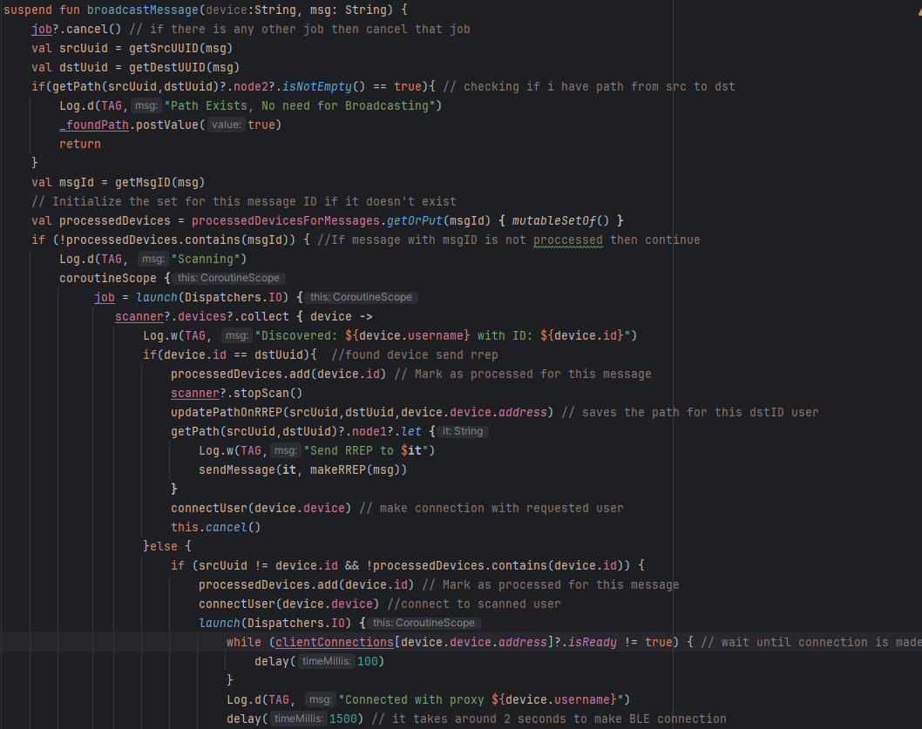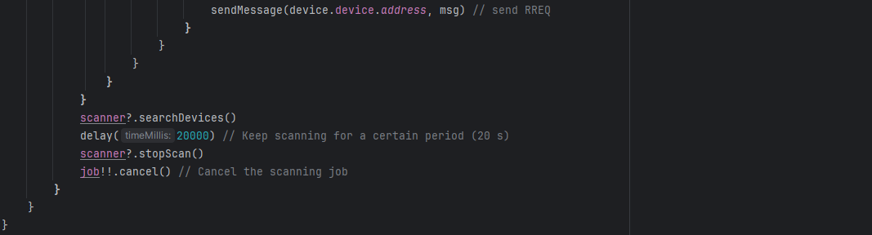

1. **Path Management**:
   * Paths are managed in a **paths** map within BluetalkServer, which tracks potential routes to destinations based on RREQ and RREP exchanges.
   * When an RREQ is received, **addOrUpdatePathOnRREQ()** updates this map with the new or existing path based on **srcID** and **dstID**.
   * Upon receiving an RREP, **updatePathOnRREP()** updates the corresponding path to include the new node, facilitating message forwarding.

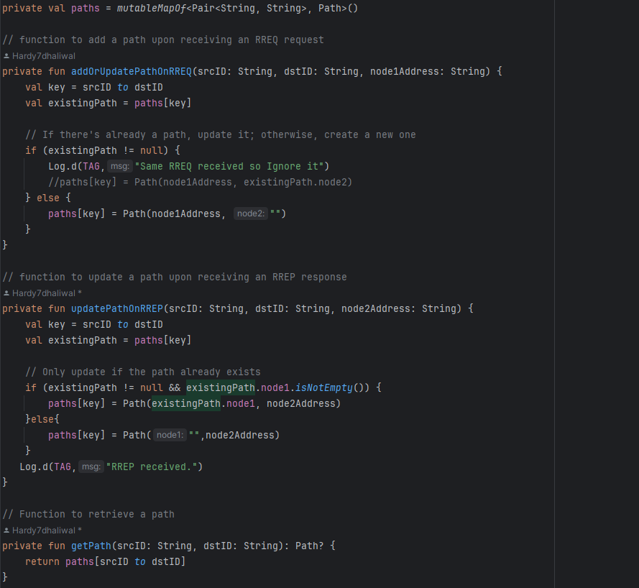

1. **Handling Responses and Forwarding**:
   * When a device receives an RREP indicating it's on the route to the destination, it forwards the message toward the **dstID**, using the path information stored in **paths**.
   * If the BluetalkServer initiated the RREQ and receives an RREP, it marks the path as found (_foundPath.postValue(true)) and uses it for future messages.
2. **Proxy Communication**:
   * For messages needing forwarding (**type == 3**), the server checks the **paths** map to determine the next hop and forwards the message accordingly.
   * This process ensures messages can be relayed through intermediate devices (proxies) until they reach the intended recipient.
3. **Encryption and Key Exchange**:
   * Messages flagged for encryption or containing critical exchange information are processed specially to ensure secure communication.
   * Key exchange messages trigger a process to derive and store shared secrets for encryption and decryption of future communications.

#### Sequence Diagram for Proxy

Figure 7 Sequence Diagram for finding proxy

The sequence diagram depicts the process within the BlueTalkie app for sending a message from one user (User A) to another (User B) through a proxy device when a direct connection between User A and User B is lost or unavailable. Here's a breakdown of what the diagram suggests:

* **Initial Message Attempt**: User A sends a message to User B via the BluetalkServer. This message is of type **0**, indicating a regular one-to-one message.
* **Detection of Disconnection**: If the BluetalkServer on User A's side detects that a direct connection to User B is lost, it initiates a procedure to find an alternative path (proxy) to deliver the message.
* **Broadcasting Route Request (RREQ)**: The BluetalkServer broadcasts a message of type **1** (RREQ), seeking a route to User B. This involves scanning for nearby devices that can act as a proxy to relay the message.
* **Proxy Discovery and Route Reply (RREP)**:
  + Devices in the vicinity of User A (potential proxies) forward the RREQ.
  + When a device (acting as the Proxy Device) identifies it can reach User B or knows the path to User B, it responds with a message of type **2** (RREP), indicating a route has been found.
* **Establishing a Path Through Proxy**: Upon receiving the RREP, the BluetalkServer updates the path information, establishing a route through the proxy to User B. This is depicted by the "Path Established Through Proxy" note, indicating successful route discovery.
* **Forwarding the Message Through the Proxy**: With the path established, the BluetalkServer sends the original message (now as type **3**, indicating a forwarded message) through the Proxy Device. This message is encrypted to ensure privacy and security.
* **Delivery and Processing at User B's Side**: The Proxy Device delivers the encrypted message to User B. The BluetalkServer on User B's side processes the received message, which includes decrypting the content.
* **Displaying the Message to User B**: Finally, the message, after being decrypted, is displayed to User B, completing the message delivery process.

### Design Choices

#### Overcoming BLE MAC Address Randomization: Implementing Proxy Mechanism via UUID

The development journey of "Blue Talkie" encountered a significant challenge during the implementation of the proxy mechanism, stemming from an inherent feature of modern Bluetooth technology: BLE MAC address randomization. This security measure, designed to protect user privacy, generates a unique and temporary MAC address for each connection session. While beneficial for security, it posed a unique challenge for "Blue Talkie's" reliance on MAC addresses for device identification and communication.

**Encountering MAC Address Randomization**

Initial tests revealed that devices could not consistently recognize each other due to the dynamic nature of MAC addresses. For instance, if Device A was connected to Device C with MAC address 1, and Device B, also connected to C, recognized C with a different MAC address (say 2), communication paths could not be reliably established. This phenomenon, known as MAC address randomization, disrupted the ability to implement a stable proxy mechanism.

**Strategic Pivot to UUID**

To surmount this obstacle, a fundamental restructuring of the app's communication strategy was required. Shifting away from MAC addresses, the app adopted UUIDs (Universally Unique Identifiers) for device identification. Upon app initialization, each device generates a unique UUID, which is then advertised alongside the user's username. This approach ensured consistent and secure device identification, independent of the underlying Bluetooth address randomization.

**Database Schema Revision**

This pivot necessitated a comprehensive overhaul of the app's database schema, which was initially predicated on MAC addresses. The transition to UUID-based identification required updating data models, storage schemas, and query mechanisms to accommodate the new identifier system.

**Proxy Mechanism Realization**

The final piece of the puzzle was the implementation of the proxy mechanism using UUIDs. This was achieved by introducing RREQ (Route Request) packets that were broadcast to all devices within range. These packets were then propagated by each receiving device to their neighboring devices, creating a chain of communication. Upon identifying the target device (identified by its UUID), a RREP (Route Reply) packet was sent back along the chain to the source device, establishing a known path for message relay. This process not only allowed for messages to be sent through proxy devices but also established a dynamic routing system that could adapt to changing network conditions.

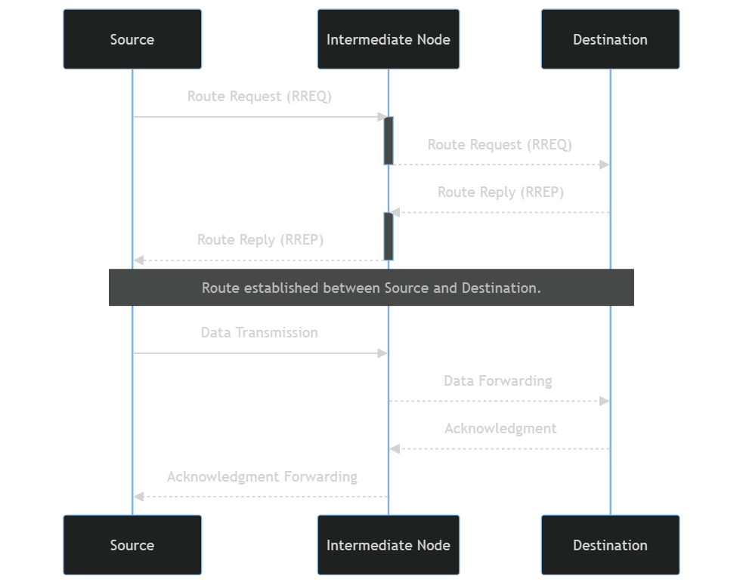

Figure 8 Sequence Diagram for Route Discovery

#### Implementing Secure Communication: ECDH and AES Encryption

In the realm of digital communication, ensuring the privacy and security of user data is paramount. "Blue Talkie" places a strong emphasis on security, particularly given its innovative use of Bluetooth technology for offline messaging. To achieve a high level of security, "Blue Talkie" incorporates advanced encryption techniques, including Elliptic Curve Diffie-Hellman (ECDH) for key exchange and Advanced Encryption Standard (AES-256) for bulk data encryption. This section delves into how these technologies are employed within the app to safeguard user communications.

**ECDH for Key Exchange**

The foundation of secure communication is the ability to securely exchange cryptographic keys between communicating parties. "Blue Talkie" utilizes ECDH, a key agreement protocol that allows two parties, each having an elliptic curve public-private key pair, to establish a shared secret over an insecure channel. This shared secret is then used to encrypt and decrypt messages between the devices.

**Key Advantages**:

* **Privacy**: ECDH ensures that the key exchange process is secure, even if a malicious entity is eavesdropping on the communication channel.
* **Efficiency**: ECDH with elliptic curve cryptography offers the same level of security as traditional Diffie-Hellman and RSA but with smaller key sizes, making it more efficient for mobile devices with limited computational resources.

**AES for Bulk Encryption**

Once a shared secret is established using ECDH, "Blue Talkie" employs AES to encrypt the actual messages sent between users. AES is a symmetric key encryption algorithm known for its speed and security, making it widely adopted across various applications and industries.

**Implementation Details**:

* **Security**: AES provides a high degree of security, making it suitable for protecting sensitive user data.
* **Performance**: Given its efficiency, AES does not significantly impact the app’s performance, ensuring that users can communicate securely without compromising on speed or battery life.

### User Guide

This step-by-step guide provides instructions on how to navigate and use the BlueTalkie app's features effectively.

#### Getting Started with Bluetooth Permissions

Upon launching BlueTalkie for the first time, you will be prompted to grant permissions essential for the app’s operation. These permissions enable the app to use Bluetooth for communication without internet dependency.

.

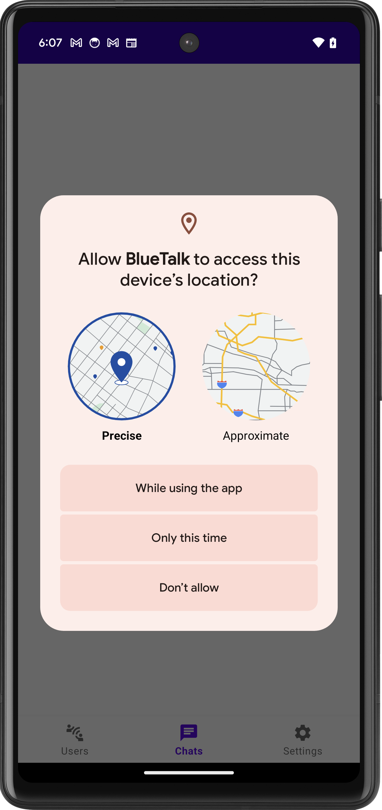 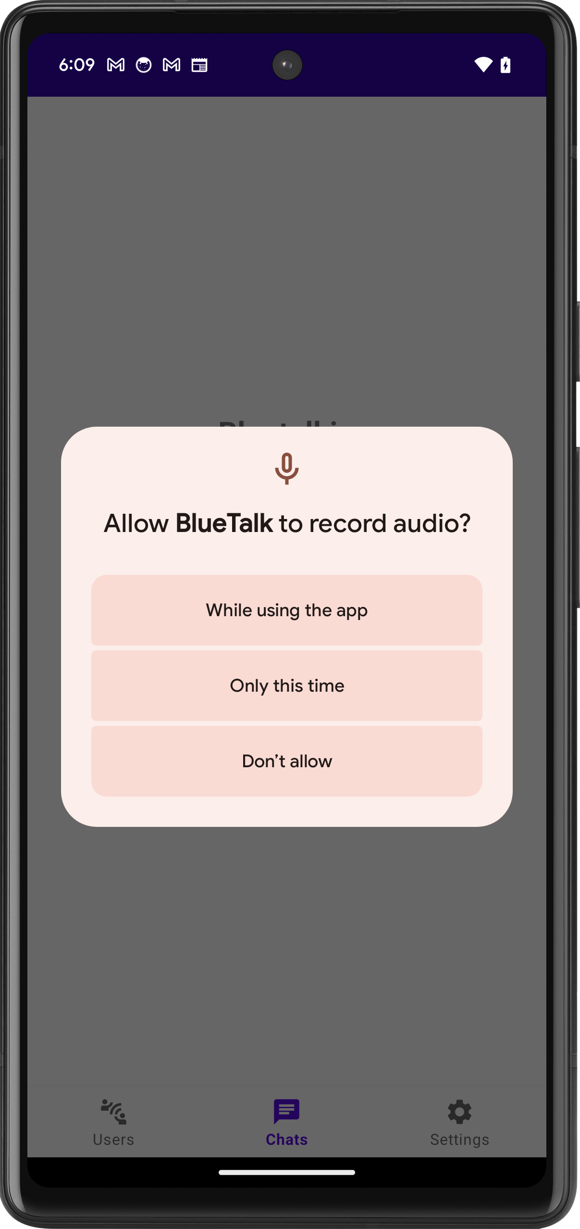 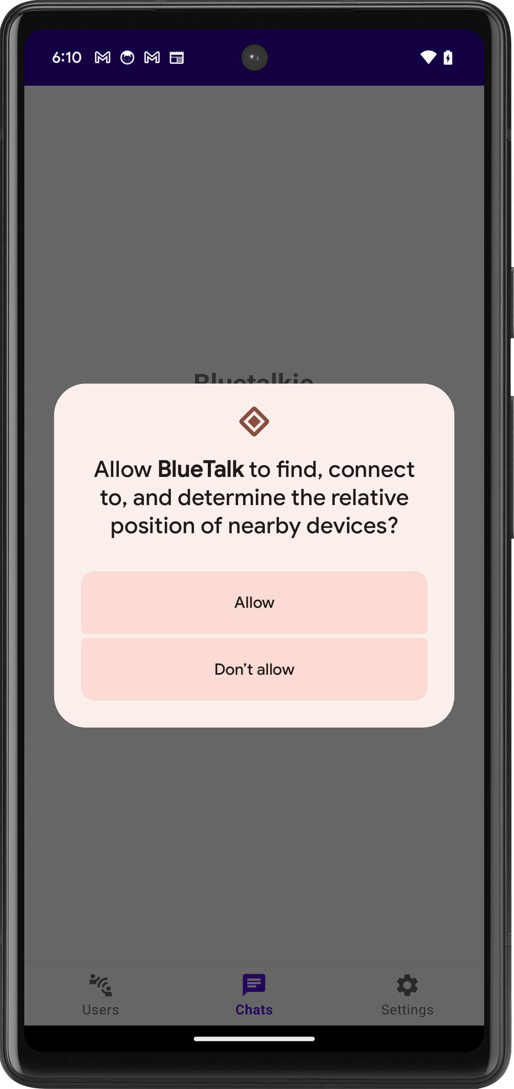

#### Handling Denied Permissions

**Initial Denial**: If permissions are initially declined, a courteous alert will explain their necessity for the app's functionality and offer the opportunity to enable them.

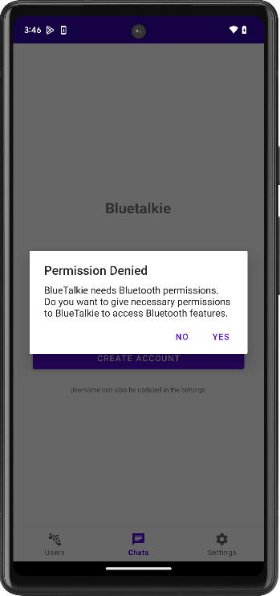

**Persistent Denial**: If you select "Don't Allow," you'll be asked if you wish the app to reattempt the permission request. If permissions are denied again, a dialog will direct you to the app's settings page, where you can manually grant permissions, which are essential for further app use.

This step is crucial because the app is restricted from making further permission requests after a certain number of denials, and manual adjustment is the only recourse.

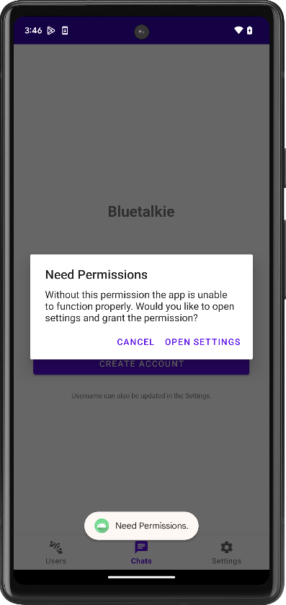 => 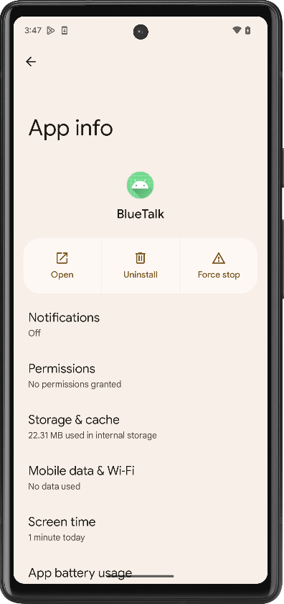

#### Establishing Your Identity in BlueTalkie

**Initial Setup: Create a Username** When you launch BlueTalkie for the first time, you'll be greeted with a screen to set up your username. This name will be your identifier to other users during Bluetooth scans, ensuring you're recognizable in the BlueTalkie network.

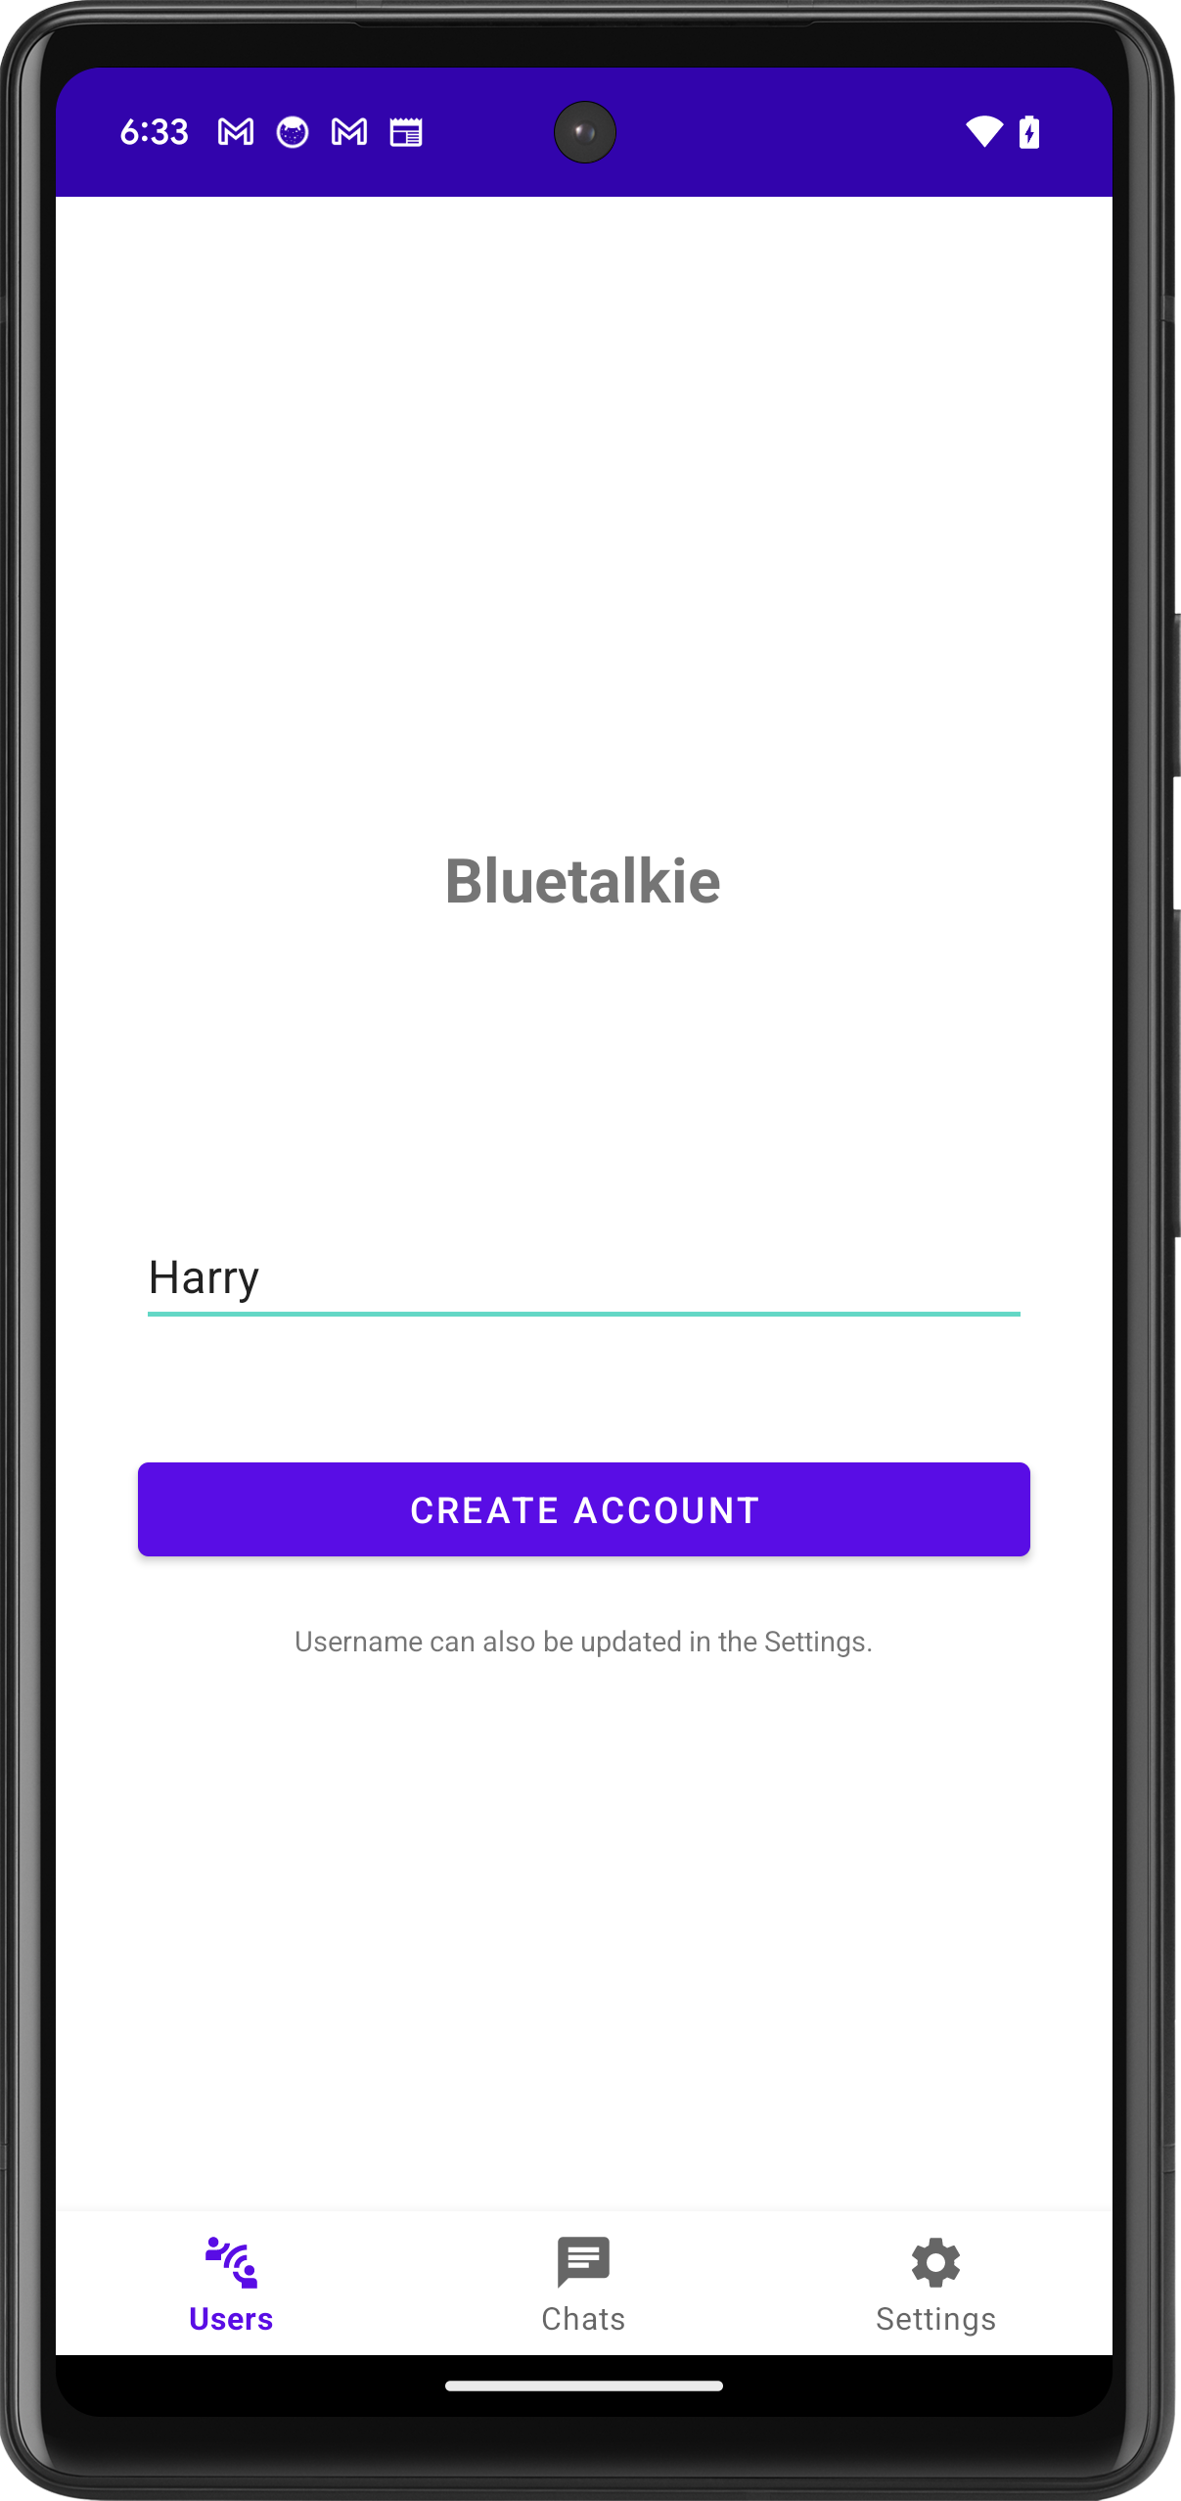

**Changing Your Username in Settings**

You can change your BlueTalkie username at any time to keep your identity fresh and relevant. Just navigate to the settings screen to update your details.

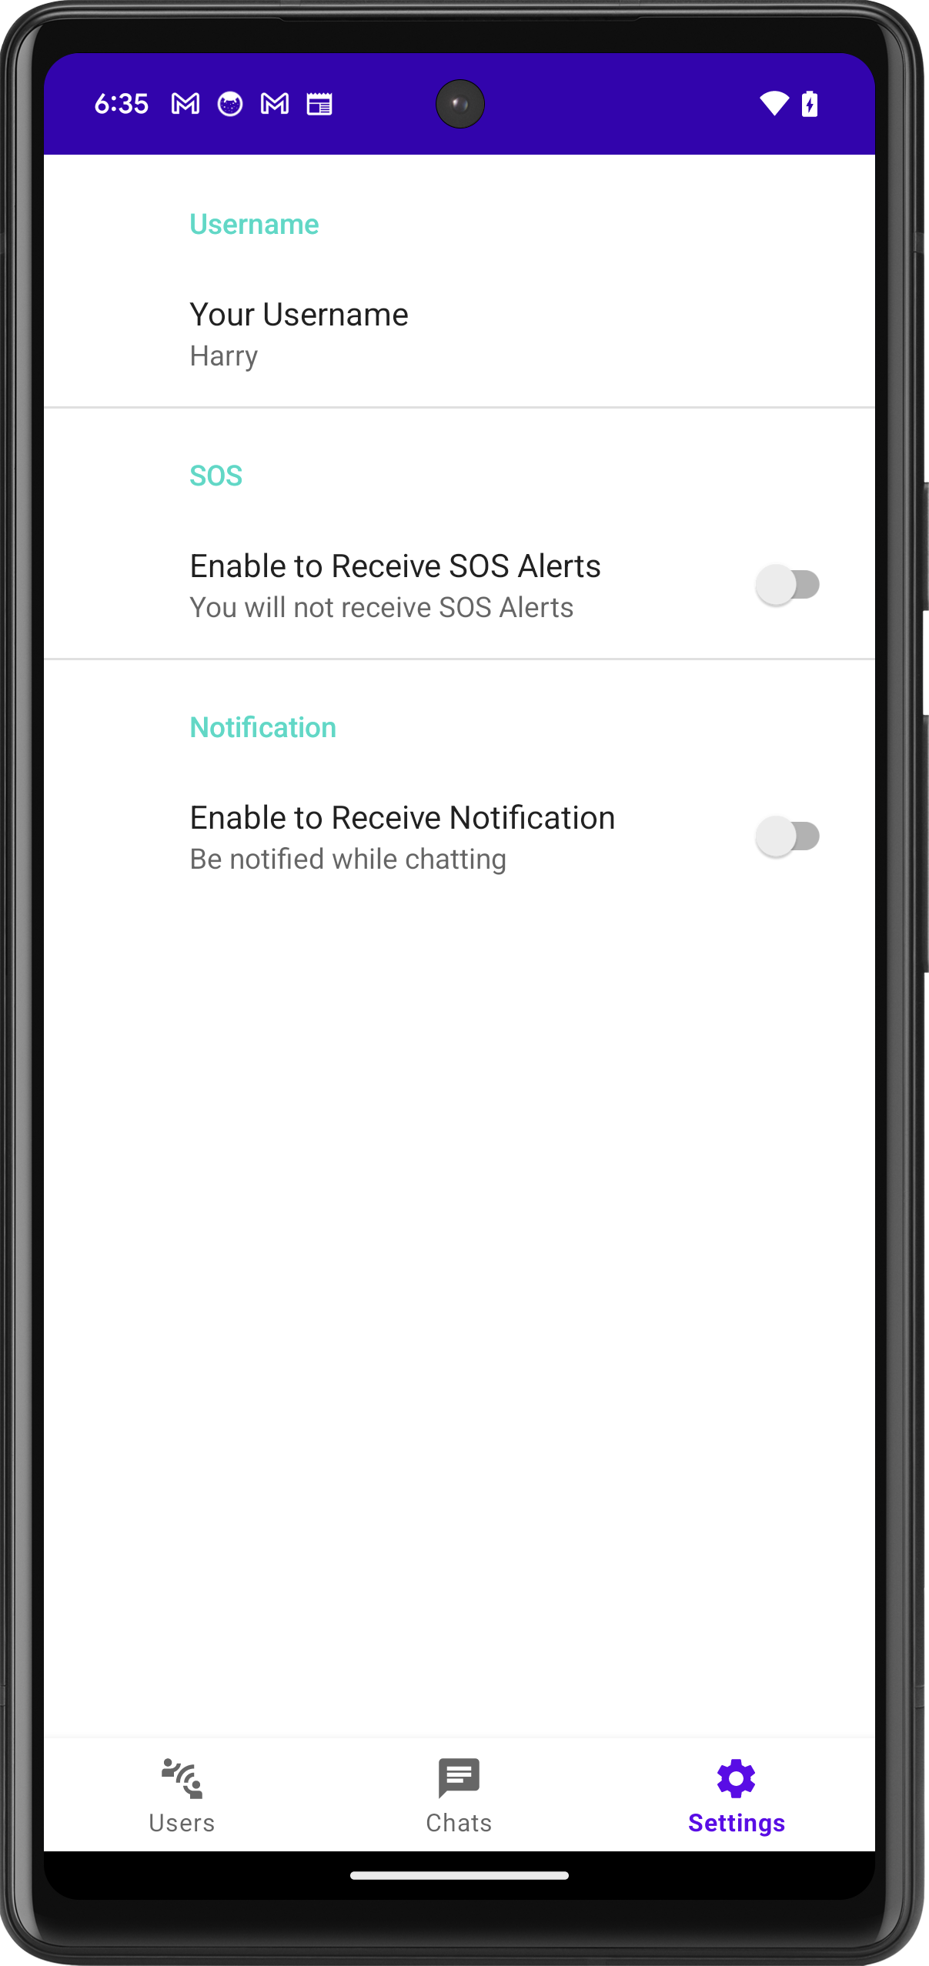 => 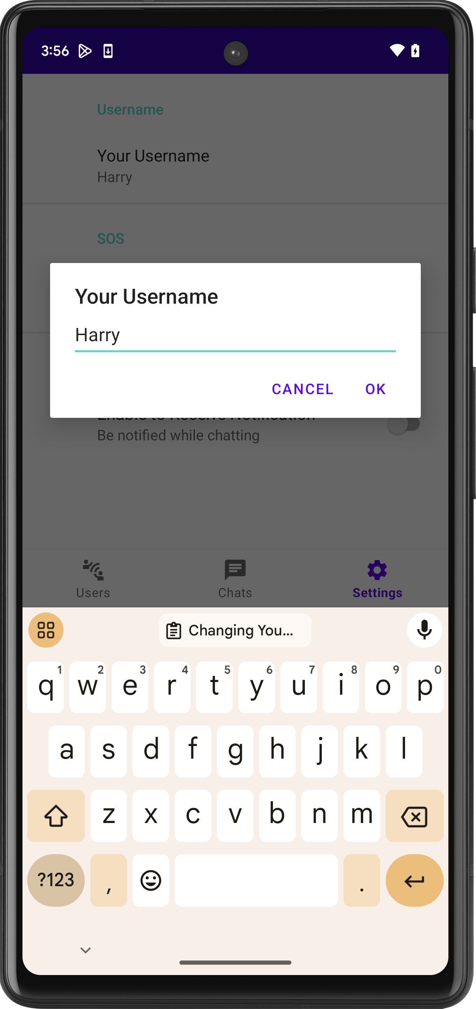 => 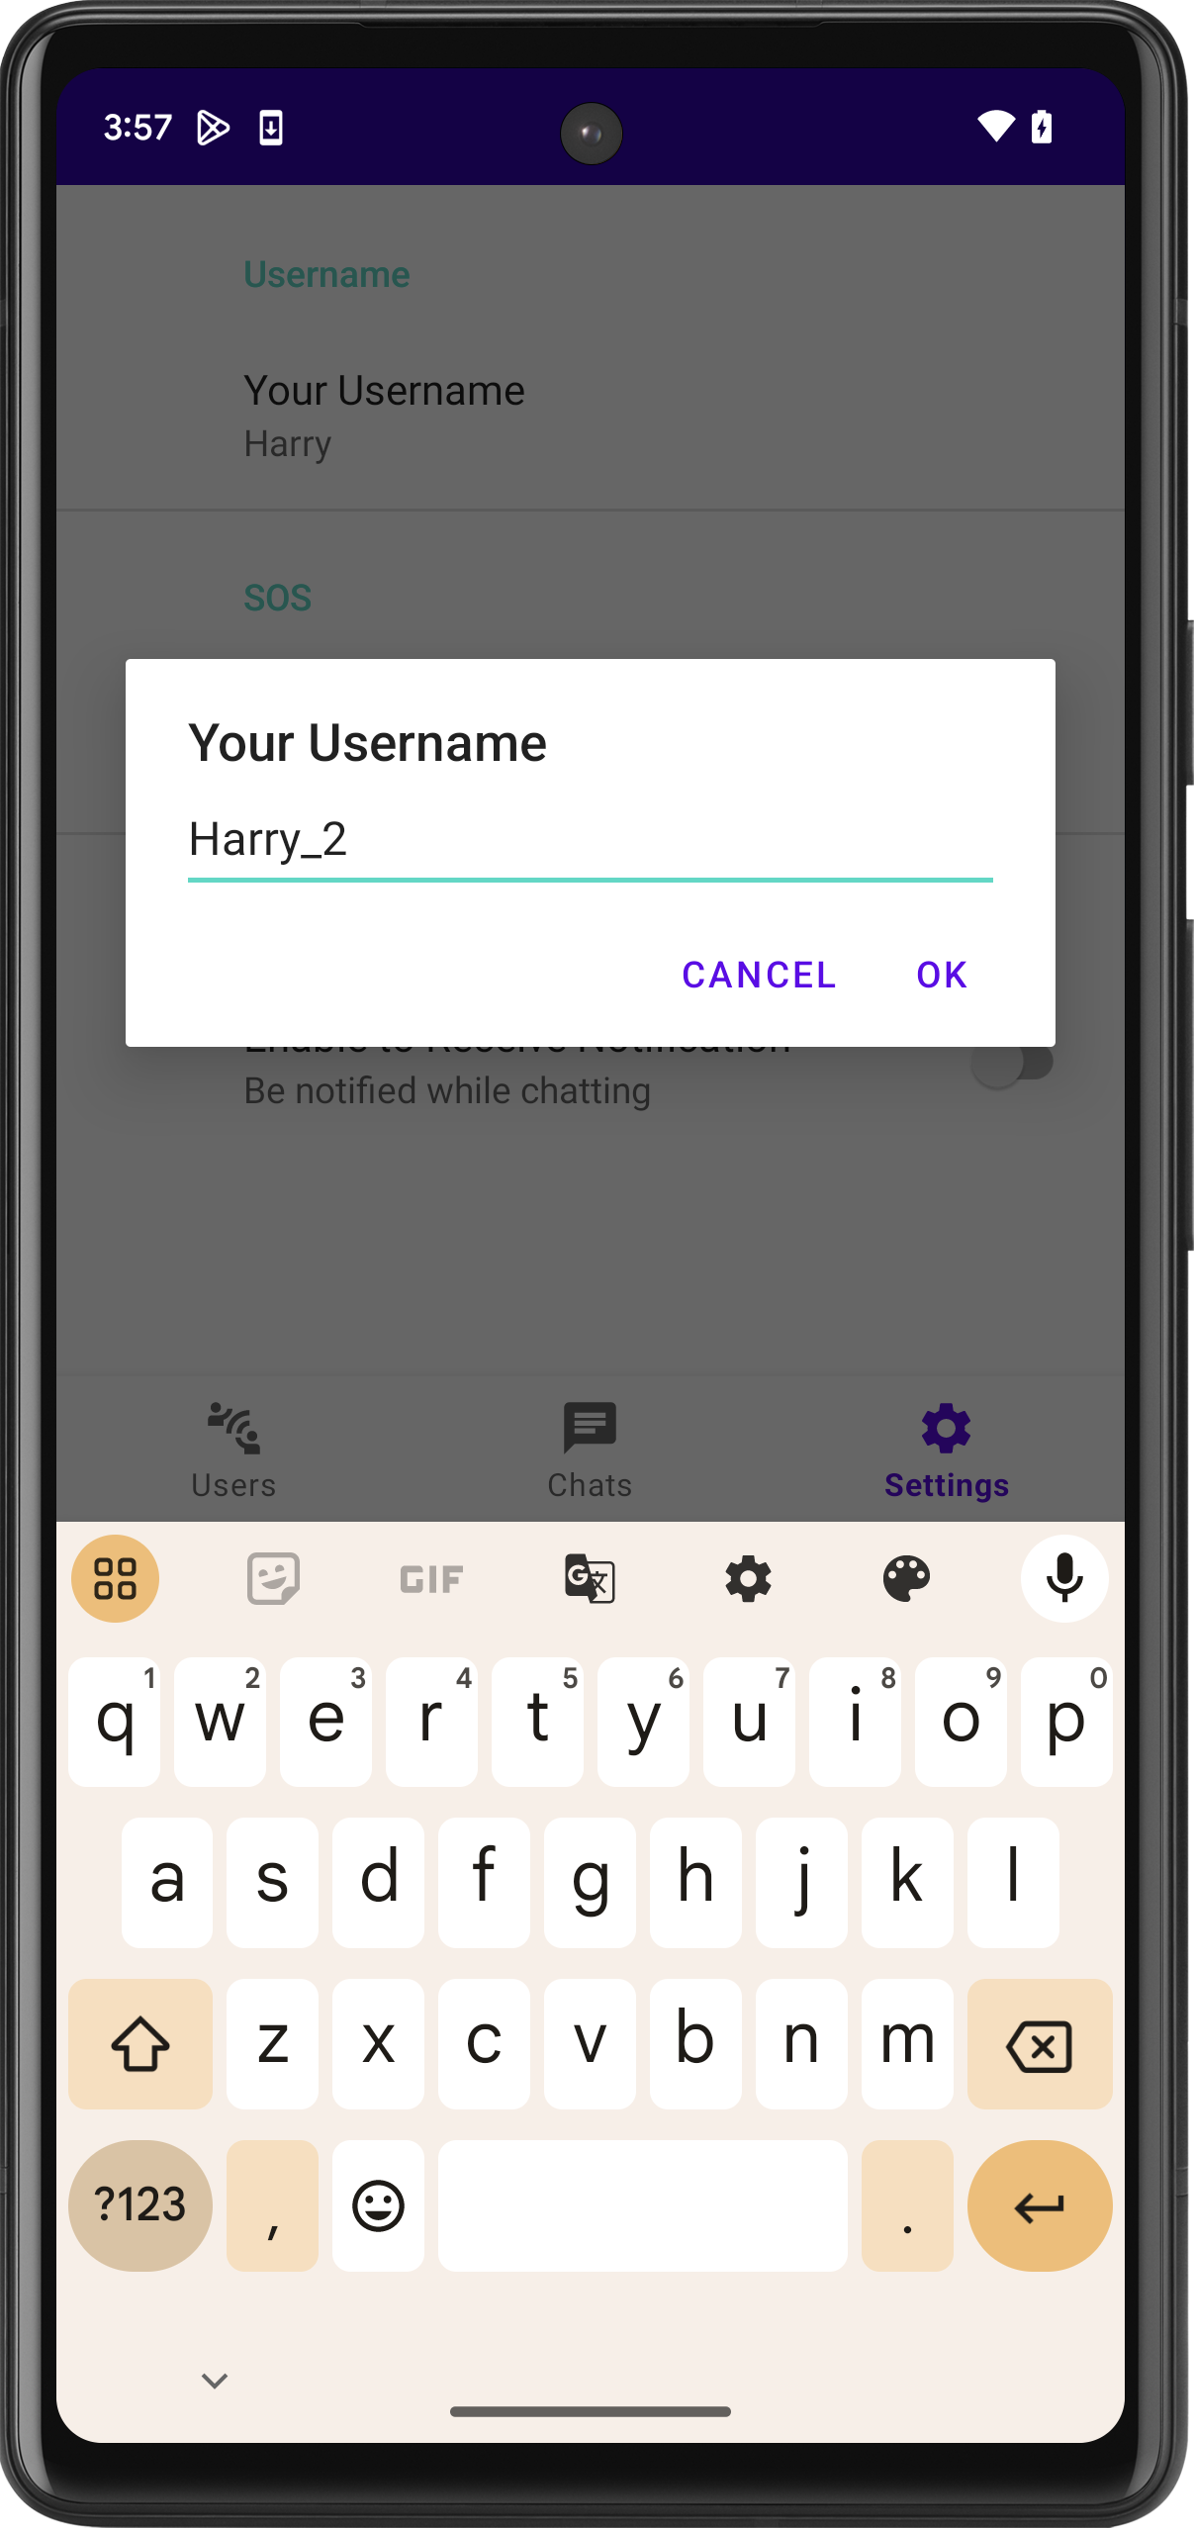

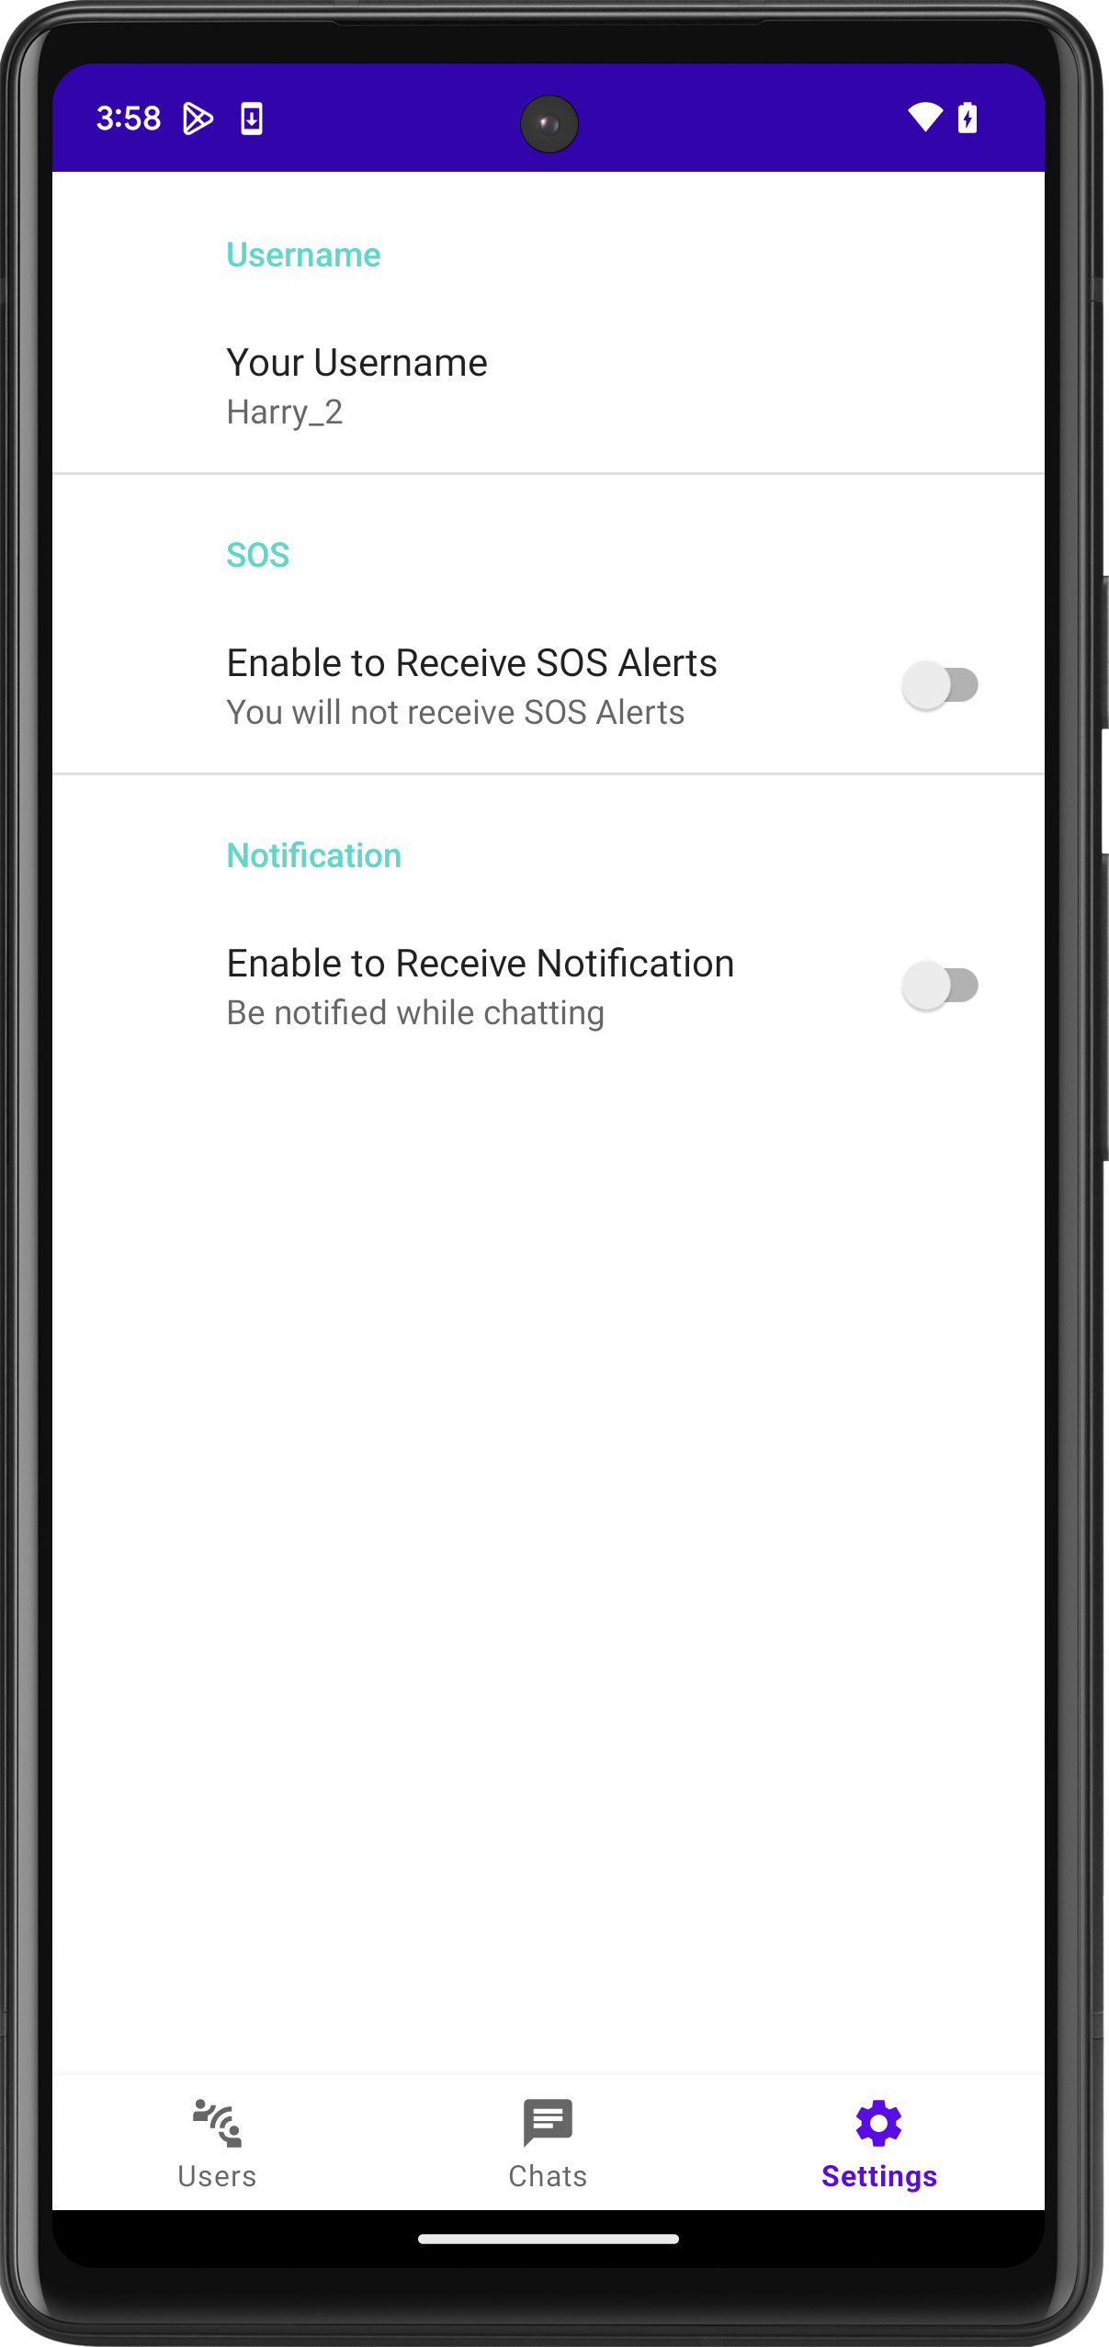

Your username is more than just a label—it's your calling card in the world of seamless, off-the-grid communication with BlueTalkie.

#### Making New Connection: Finding Nearby Users

With your unique username established, BlueTalkie is all set to bridge connections with people nearby. Head over to the "Users" tab, where the app showcases a list of active users within your Bluetooth range. This intuitive feature enables you to swiftly identify and connect with peers around you. Tap on a user to initiate a chat and interact in real-time.

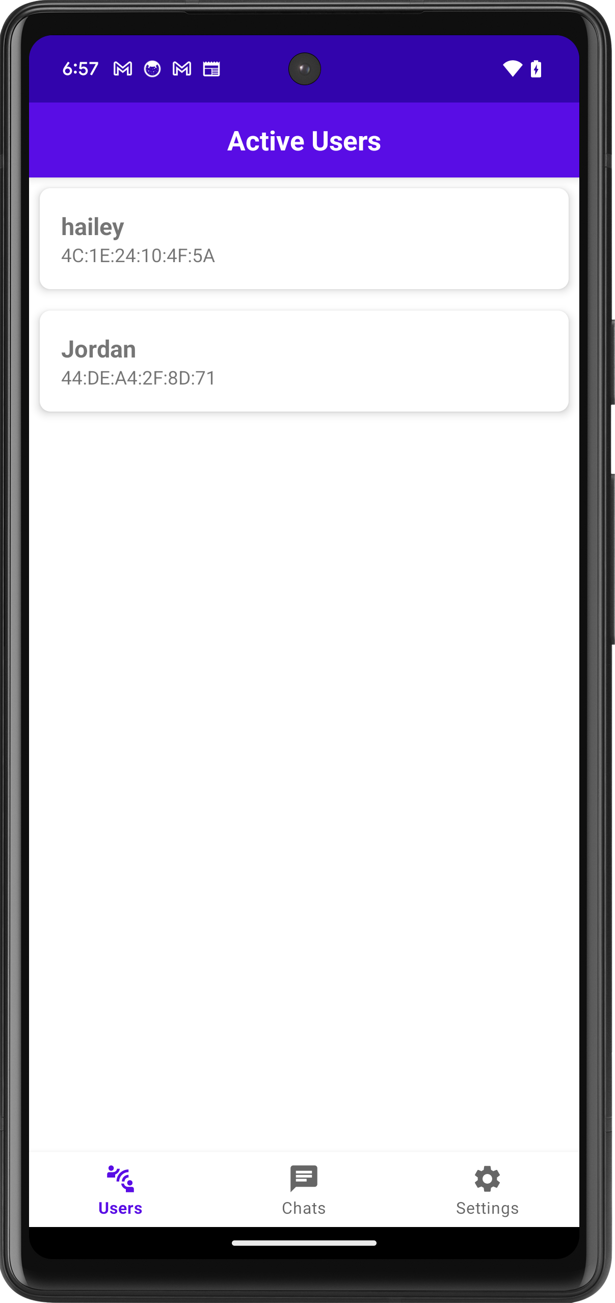

Engage effortlessly with those around you, whether you are in a cafe, at a conference, or enjoying a concert. BlueTalkie brings social interactions closer without the need for an internet connection.

#### Starting Conversations: Chatting with Users

Selecting a user takes you to a private chat screen. Once connected, you can opt for encrypted chat for private conversations. The chat interface indicates the connection's status, ensuring you are informed about the chat's security.

* + User Selects on one of the listed users.

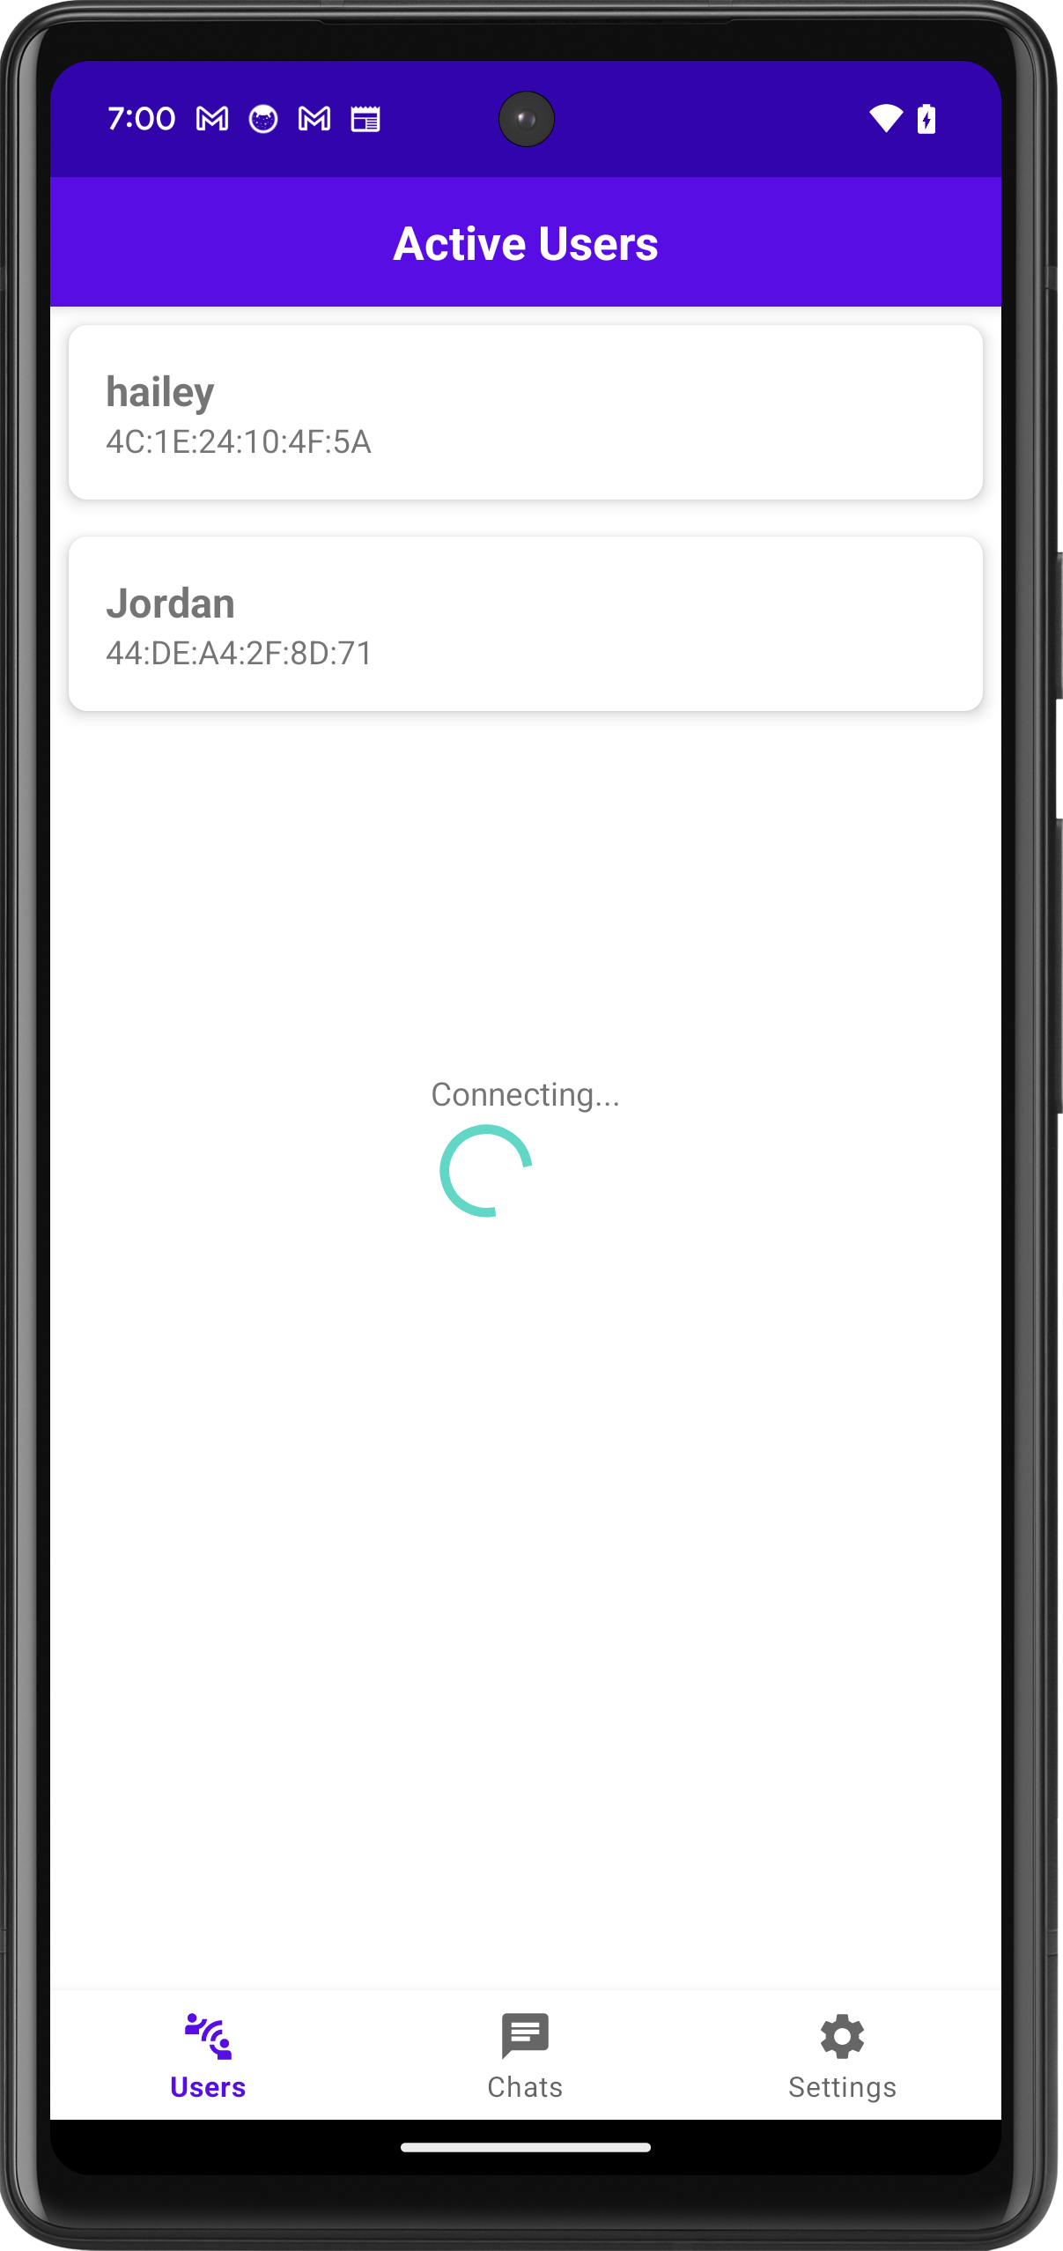



* + Upon entering the chat space, before the conversation starts, the app presents an option to enable encrypted chat. This is a security feature designed to ensure privacy and confidentiality in communication between users.

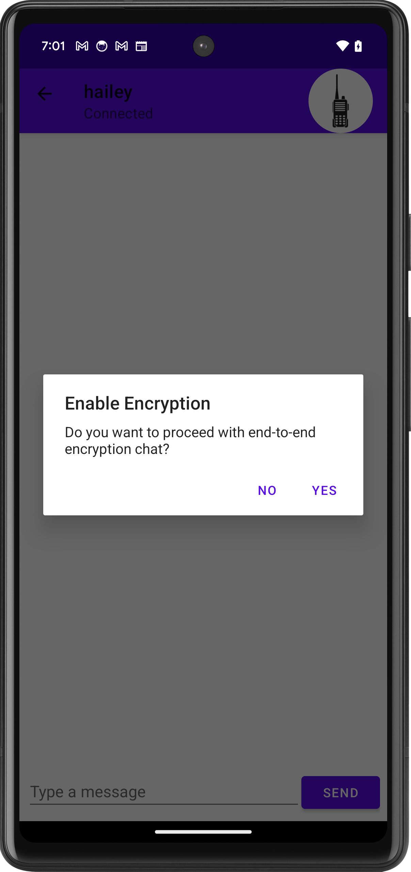

* + Now User can send messages.

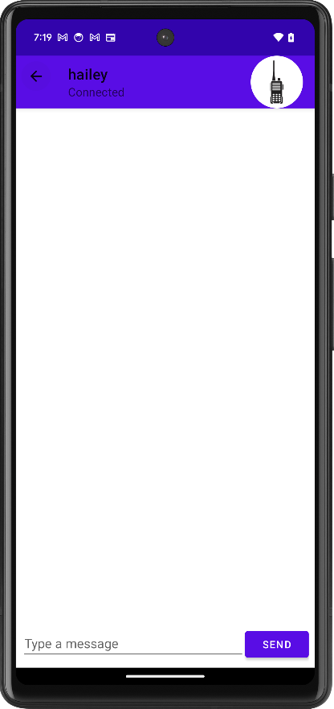 => 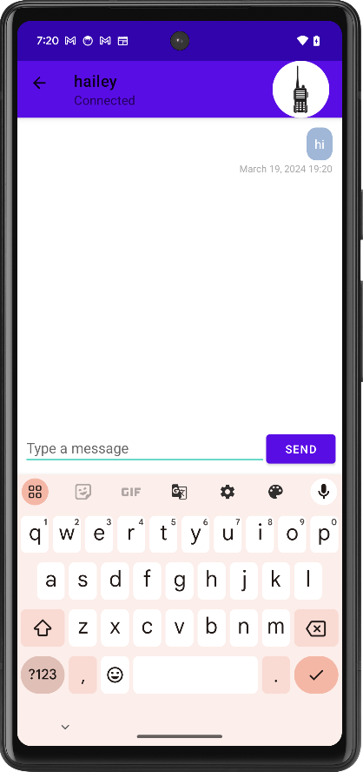

#### Revisiting Past Chats: your Chat History

"Blue Talkie" is designed with the user's convenience in mind, particularly when it comes to navigating past conversations. This feature allows users to seamlessly revisit and continue their discussions, ensuring that no communication is lost in the shuffle. Here’s a step-by-step guide on how users can access and interact with their chat history:

* **Accessing Chat History**:
  + Upon opening the "Blue Talkie" app, users are directed to the Chats screen. This interface presents a chronological list of all past conversations. Each entry in the list displays the most recent message sent or received, the sender's username, and the time the last message was exchanged. This design choice ensures that users have immediate context for each conversation immediately.

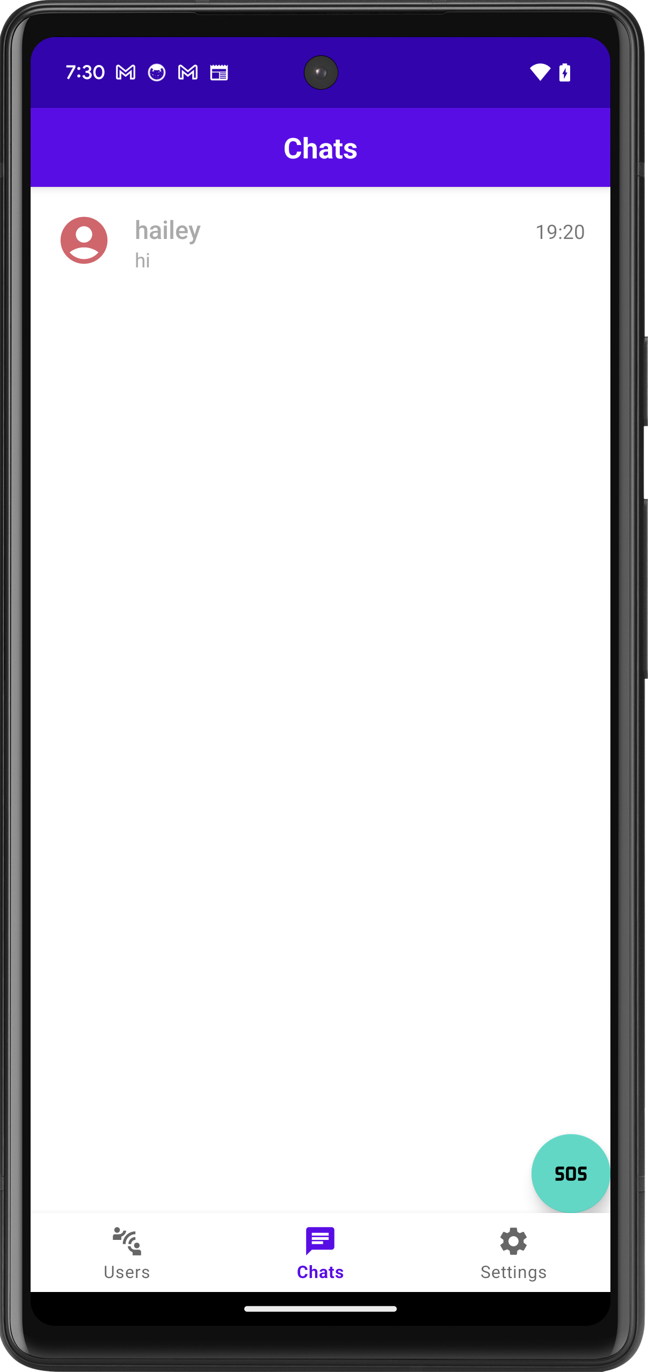

* **Selecting a Conversation**:
  + To dive back into a conversation, users simply tap on their desired chat. This action opens the conversation screen where all previous messages are displayed. This seamless transition from the chat overview to the detailed conversation allows users to catch up on missed messages or recall the context of their discussions quickly.

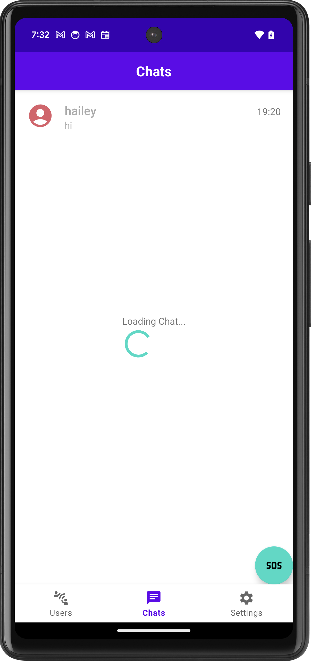

* **Encryption Permission Dialog**:
  + Before resuming messaging, "Blue Talkie" prioritizes user security by prompting them to decide on encryption for their conversation. This dialog box is a critical feature, reinforcing the app's commitment to privacy and secure communication. Users are given the choice to enable or disable encryption, ensuring that they have control over their conversation's security parameters.

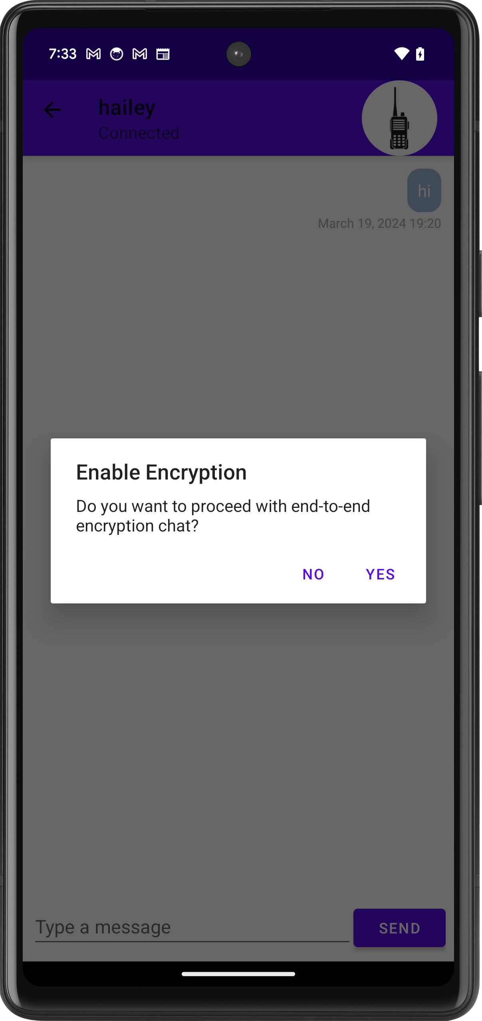

* **Continuing the Conversation**:
  + Following the encryption selection, users are free to continue their conversation. They can send and receive messages as usual, with the app handling encryption in the background if enabled. This process is designed to be intuitive and non-intrusive, maintaining a focus on user experience while ensuring communication security.

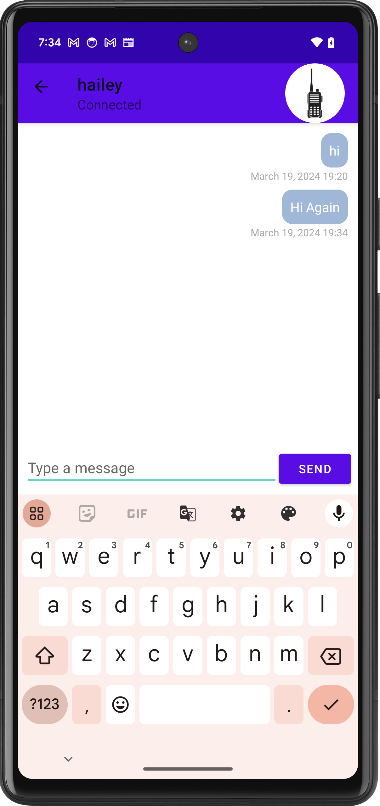

#### Direct Voice Communication: Using the Walkie-Talkie

"Blue Talkie" enhances your chatting experience by incorporating a Walkie-Talkie feature for real-time voice messages. Here's how to use it:

1. **Access Walkie-Talkie**: In an active chat, click on the radio icon to bring up the Walkie-Talkie feature.

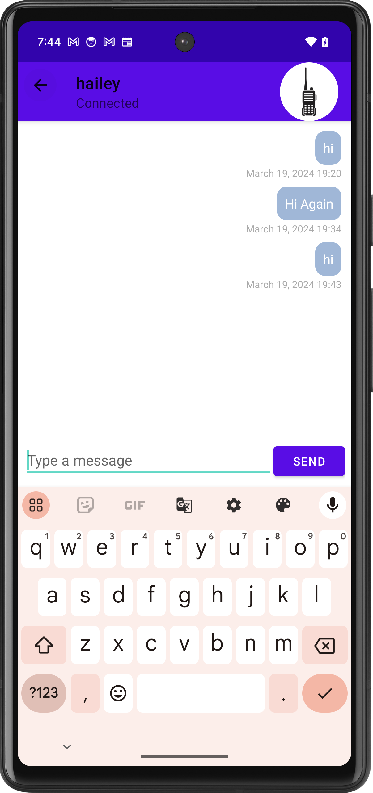

1. **Push-to-Talk Popup**: A popup with a push-to-talk button will appear.

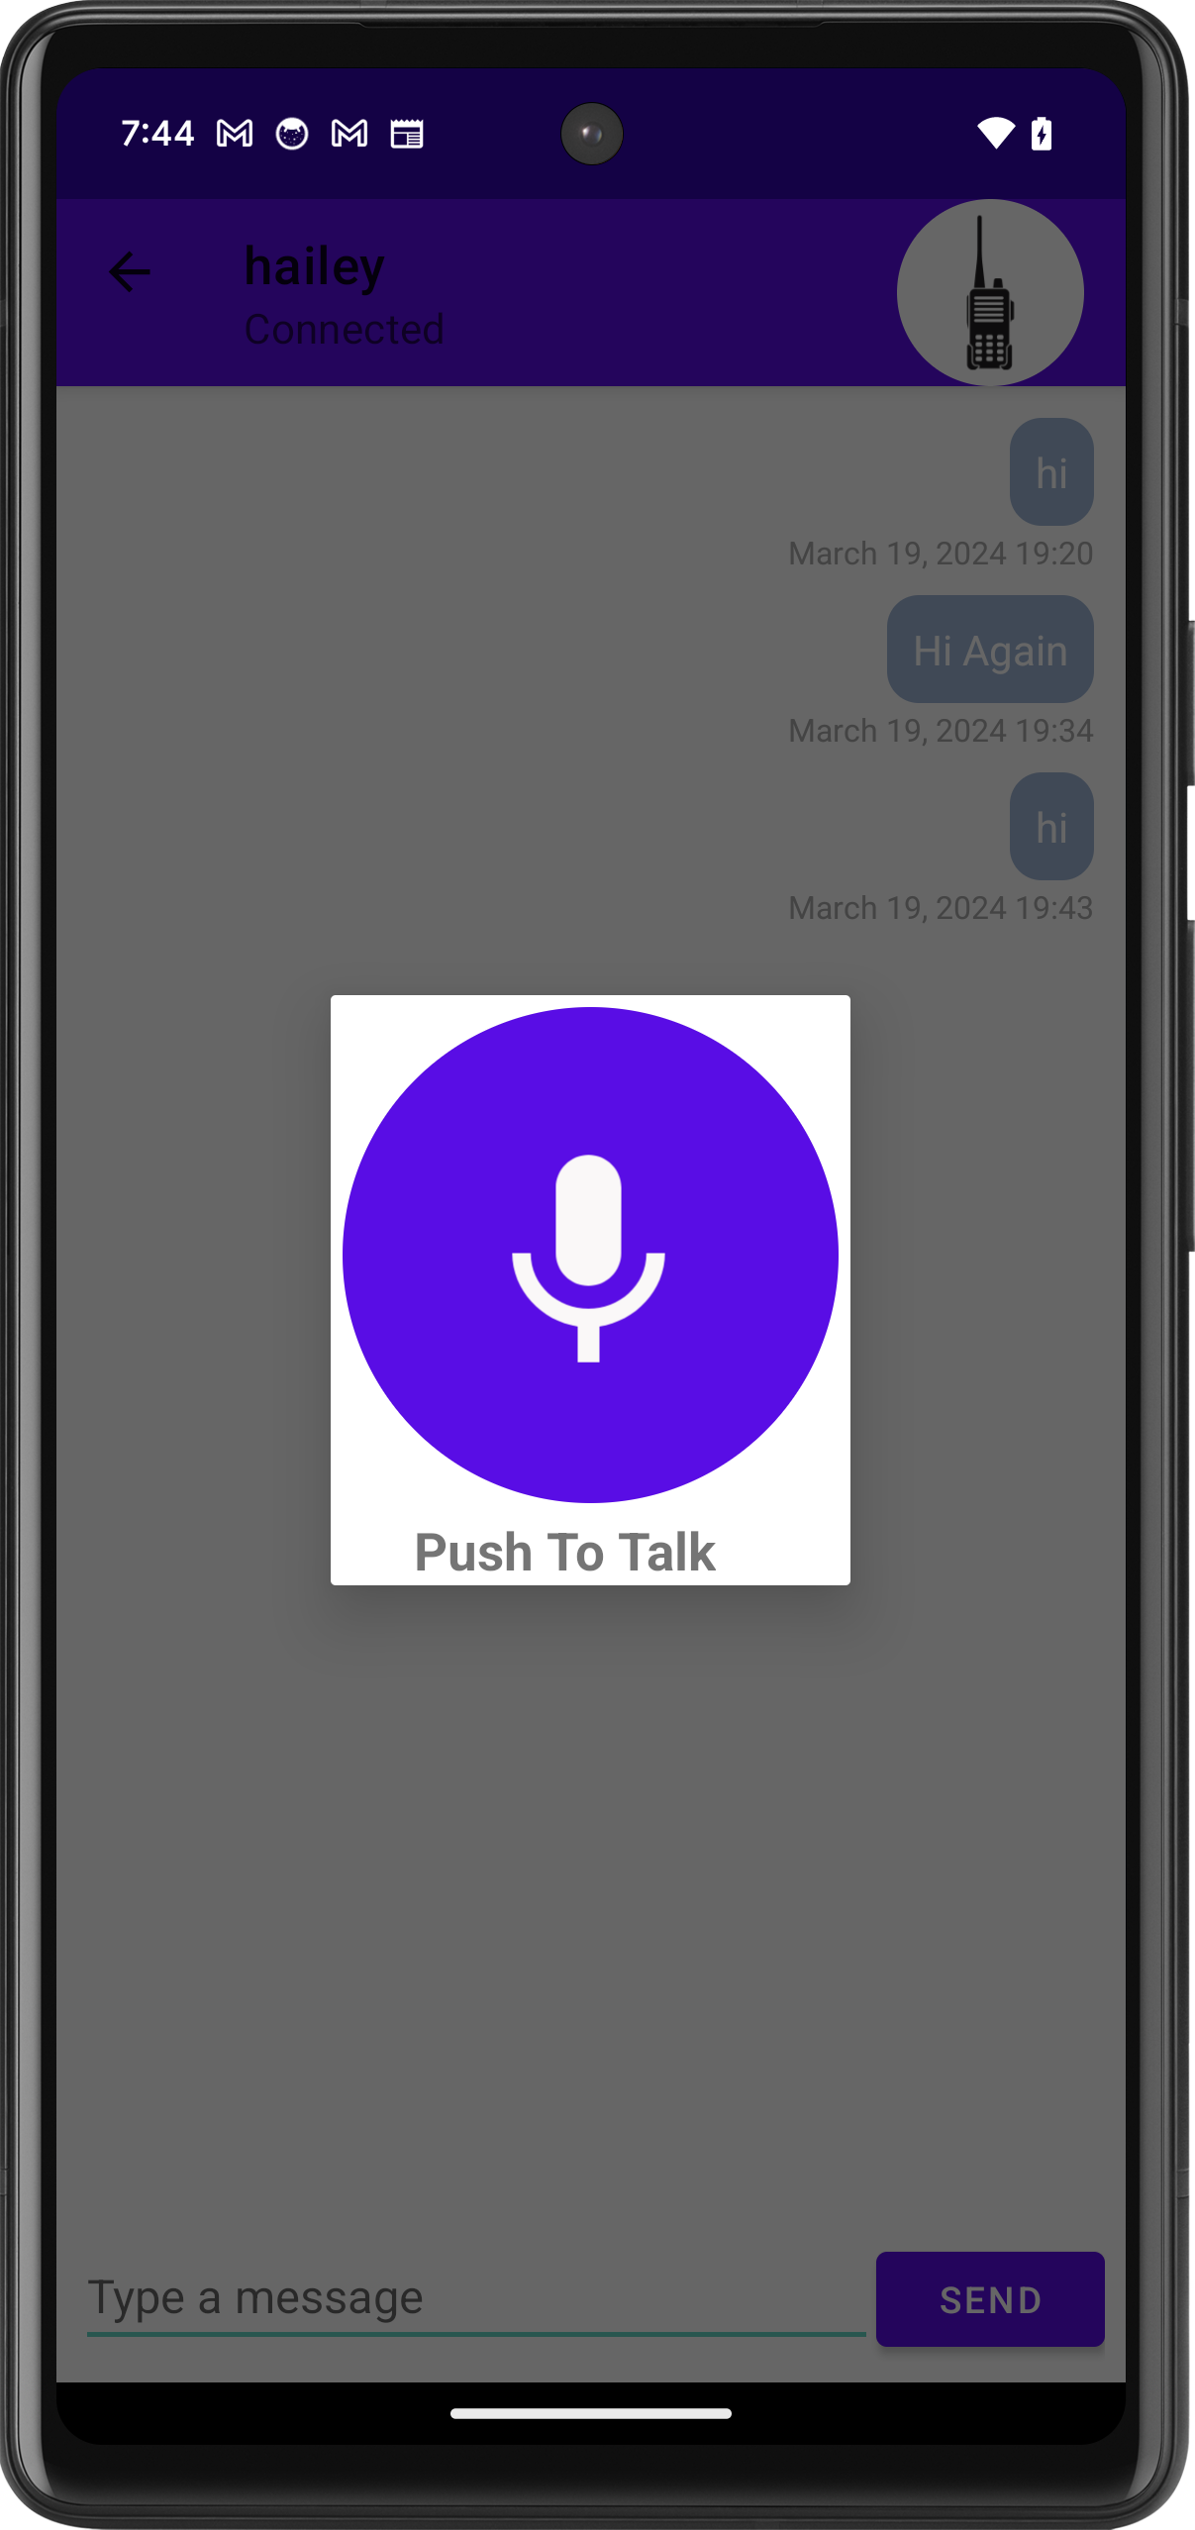

1. **Send Voice Message**: Press and hold the button, speak your message, then release it to send instantly.

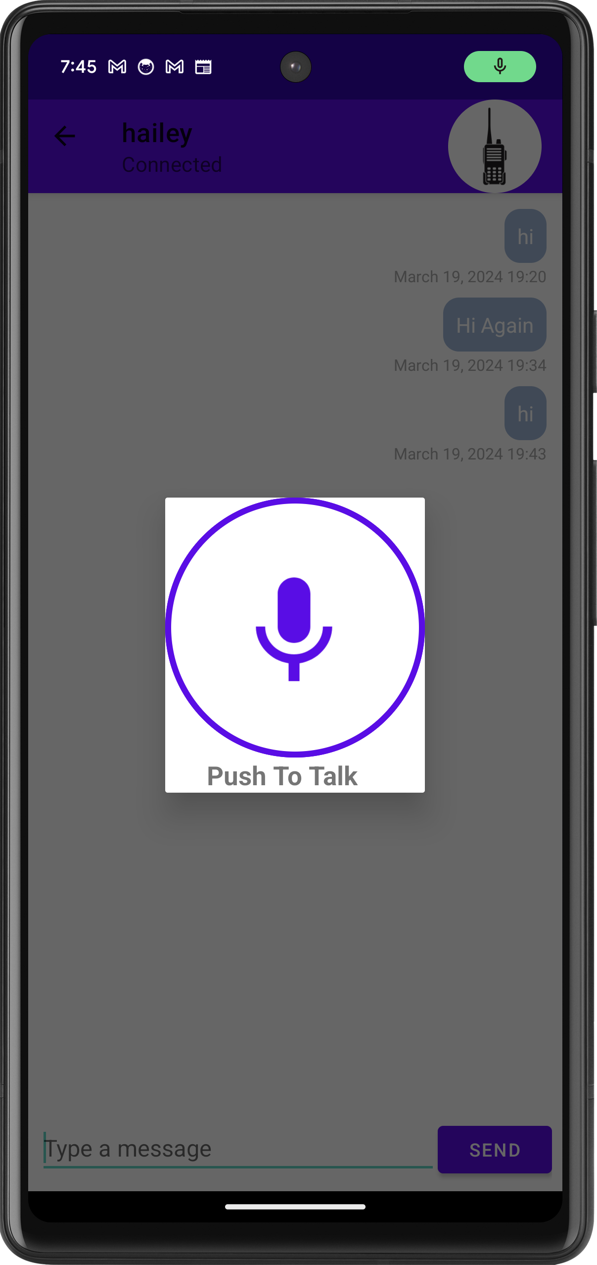

#### Emergency Broadcast: Sending an SOS

In emergencies, the SOS feature broadcasts an alert to nearby users. A tap on the SOS button on the Chats screen will prompt you to confirm the broadcast, potentially alerting others to your need for assistance.

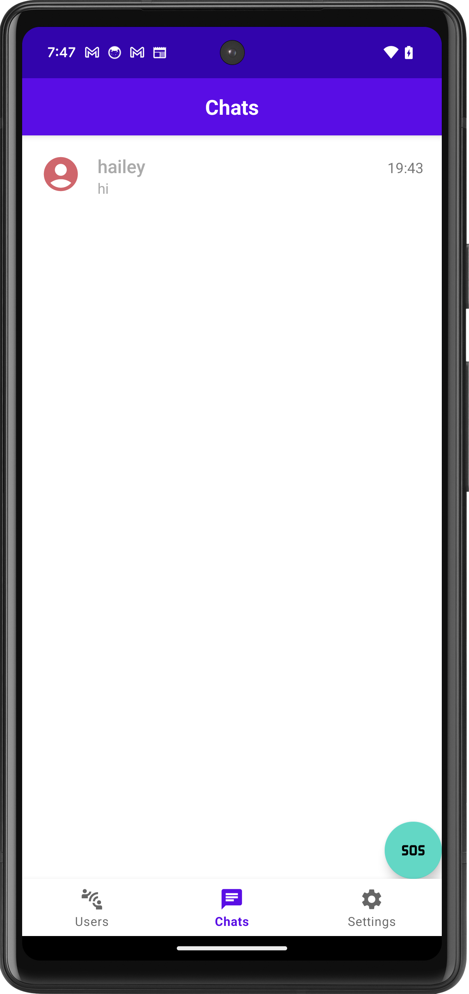 => 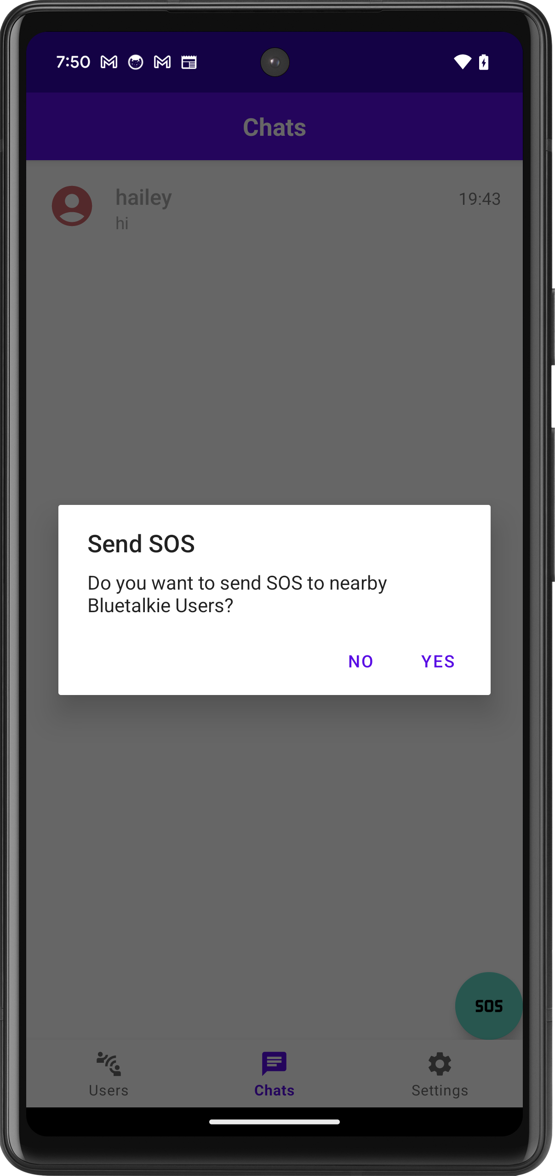 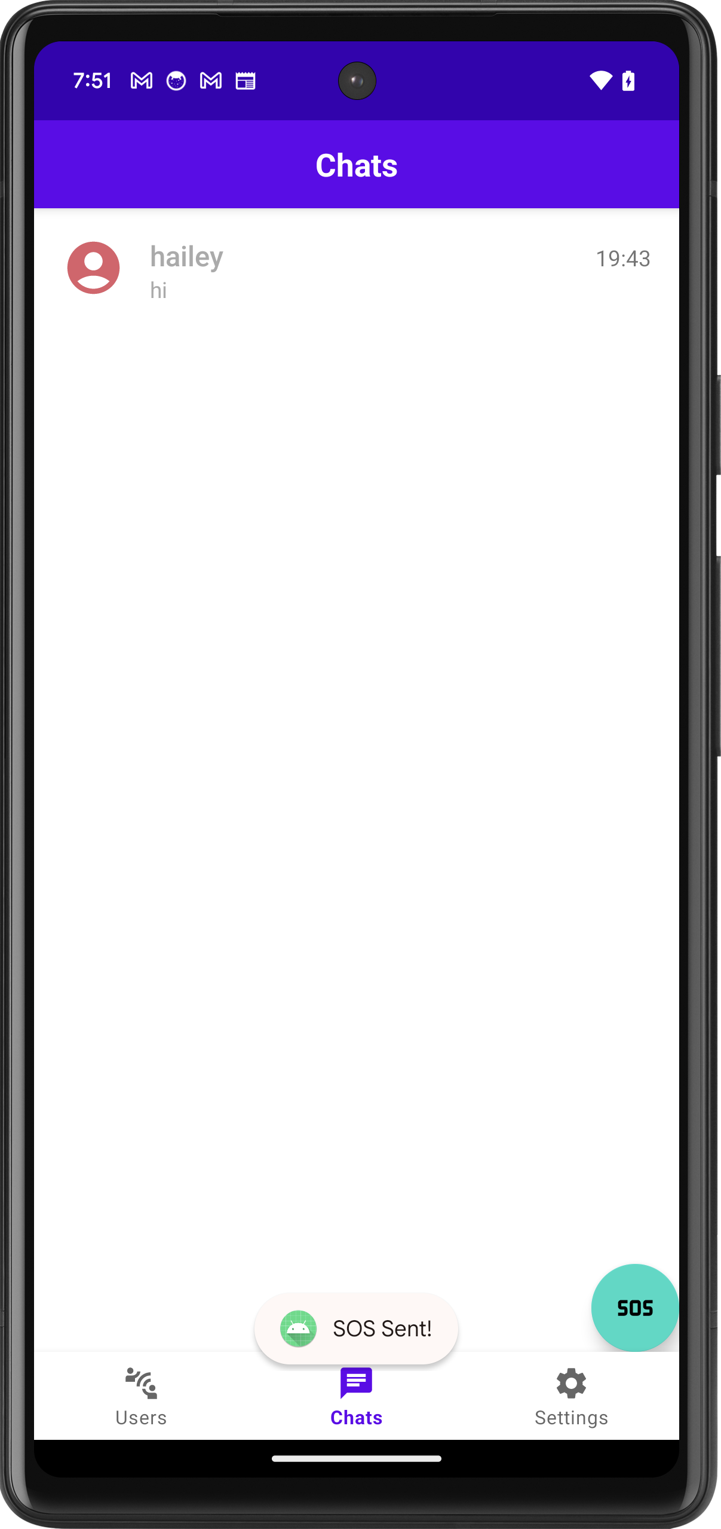

BlueTalkie is designed with simplicity at its core, ensuring a user-friendly experience where all features are readily accessible and self-explanatory.

## Testing Details and Results

### Database Testing

The database testing phase focused on verifying the correct functionality of the data layer within the application. This included tests for data insertion, retrieval, updating, and integrity constraints. The results are as follows:

* **getConversations_returnsLatestMessages**: Confirms that the latest messages from each conversation are being correctly fetched, ensuring the chat view displays the most recent messages.
* **insertAndGetMessagesForUser**: Validates the insert operation for messages and subsequent retrieval for a specific user, crucial for chat functionality.
* **insertAndGetUserByAddress**: Tests if users can be inserted and then fetched based on their Bluetooth addresses, important for user recognition and management.
* **getAllUsers**: Ensures all users are fetched correctly, which is vital for user management and displaying available contacts.
* **duplicateUsers**: Checks the database's ability to handle potential duplicate user entries, maintaining data integrity.
* **updateUserFields**: Assesses the update operation for all fields associated with a user, a necessary feature for maintaining up-to-date user information.
* **updateUsername**: Tests updating the username field, necessary for reflecting changes in user identity or preferences.
* **userExists**: Checks whether the logic to detect existing users based on unique identifiers works correctly.
* **insertAndGetUserByUUID**: Ensures users can be correctly inserted and retrieved by their unique identifier, which is fundamental to user tracking and interactions.
* **updateUserAddress**: Verifies the update operation for a user's Bluetooth address, which is necessary when managing changes in device information.

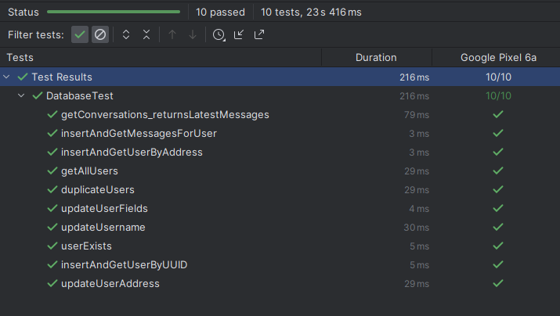

All the tests were executed on a Google Pixel 6a device and completed successfully in a total time of 23 seconds and 416 milliseconds, providing confidence in the reliability and robustness of the database layer of the application.

### UI Testing

The BlueTalkie app underwent a series of automated UI tests to validate the functionality and responsiveness of the user interface. Espresso, a powerful tool provided by the Android Testing Support Library, enabled the simulation of user interactions within the app environment. These tests are designed to assert the correct behavior of the application under various user-driven events*.*

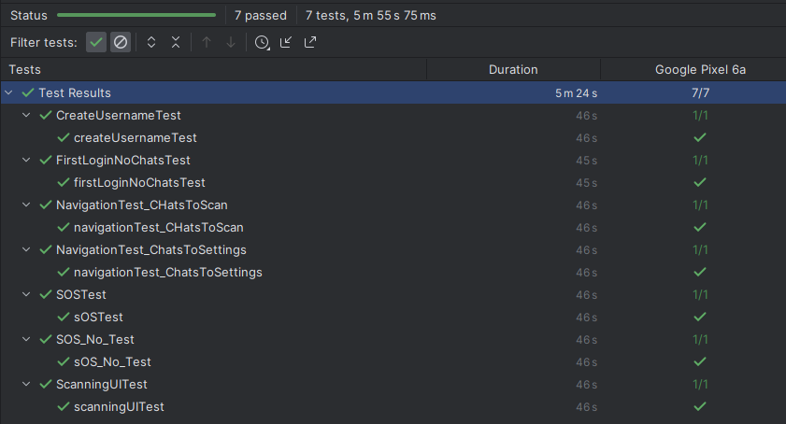

**Test Suite Details:** The UI test suite included the following critical tests:

* **CreateUsernameTest**: This test checked the user’s ability to create a username upon the first launch of the app. It simulated text entry and validated the persistence of the username for subsequent sessions.
* **FirstLoginNoChatsTest**: Aimed at new users, this test verified that the "No Chats" message was displayed correctly when the chat list was empty upon the initial login.
* **Navigation Tests**: A series of navigation tests ensured seamless transitions between different fragments of the app:
  + **ChatsToScan**: This test confirmed the functionality of navigating from the 'Chats' screen to the 'Scan' section, where users find nearby Bluetooth devices.
  + **ChatsToSettings**: Checked the navigation flow from the 'Chats' screen to the 'Settings' where users can alter their preferences and app configurations.
* **SOSTest**: Simulated the action of sending an SOS message, ensuring the app correctly broadcasted the alert to other devices.
* **SOS_No_Test**: Ensured that declining to send an SOS message after triggering the action did not result in a broadcast, preserving user intent.
* **ScanningUITest**: Assessed the scanning interface for discovering nearby users, ensuring that the UI elements updated accordingly and reflected the app's state.

### Acceptance Testing

The acceptance testing was primarily conducted through manual tests to assess the overall user experience, interface usability, and real-world Bluetooth functionality. Key user stories and scenarios were identified and systematically tested, ensuring the application meets business requirements and user expectations. The manual nature of these tests was essential due to the intricate nature of Bluetooth operations and user interactions that are challenging to automate. The successful completion of acceptance testing signified the application's readiness for production release.

#### Setup Username and Advertise That Username

1. **Objective**: Verify the app allows users to set up a unique username and advertise it over Bluetooth for discoverability.
2. **Steps**:

* Open the app.
* Enter a username on the profile page and save the changes.
* Check if the app starts advertising the username over Bluetooth.

1. **Expected Outcome**: Other devices should be able to discover the device with the specified username.
2. **Test Results**: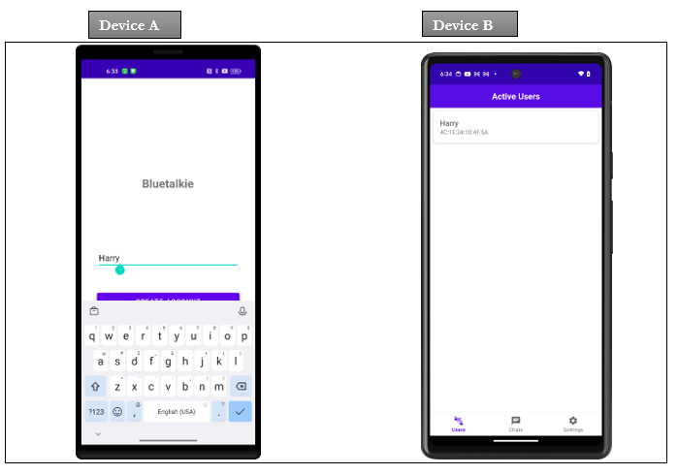

#### Change Username and Advertise That Username

1. **Objective**: Verify the app allows users to change their username and advertise it over Bluetooth for discoverability.
2. **Steps**:
   1. Open the app and navigate to Settings.
   2. Enter a username and save the changes.
   3. Check if the app starts advertising the username over Bluetooth.
3. **Expected Outcome**: Other devices should be able to discover the device with the changed username.
4. **Test Results:**



#### Discover Devices

* **Objective**: Ensure the app can discover other devices advertising their usernames via Bluetooth.
* **Steps**:
  1. Navigate to the "Users" section of the app.
  2. Initiate a scan for nearby devices.
* **Expected Outcome**: The app lists all devices within range advertising their usernames.
* **Results:**

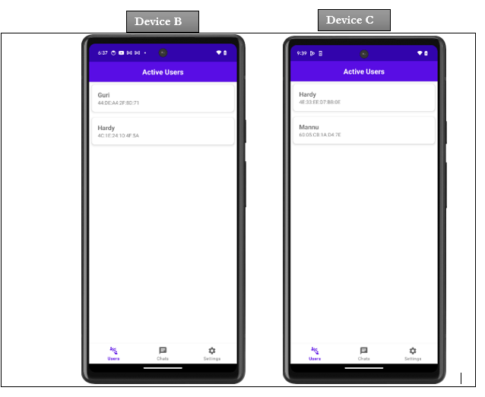

Both Devices

Can Discover Devices/Users

#### Establish Bluetooth Connection

1. **Objective**: Test the app's ability to establish a direct Bluetooth connection with another device.
2. **Steps**:
   1. From the list of discovered devices, select a device to connect to.
   2. Confirm the connection on both devices if necessary.
3. **Expected Outcome**: A stable Bluetooth connection is established, allowing for direct communication.
4. **Results:**

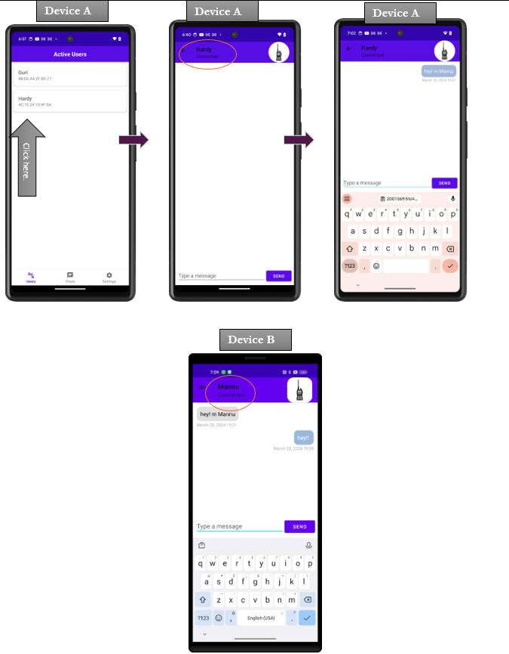

#### Send Messages (Disable Encryption)

* **Objective**: Check the messaging functionality without encryption.
* **Steps**:
  1. With a Bluetooth connection established, navigate to the chat interface.
  2. Send a message to the connected device with encryption disabled.
* **Expected Outcome**: The message is received by the connected device and can be read as sent.
* **Result**:

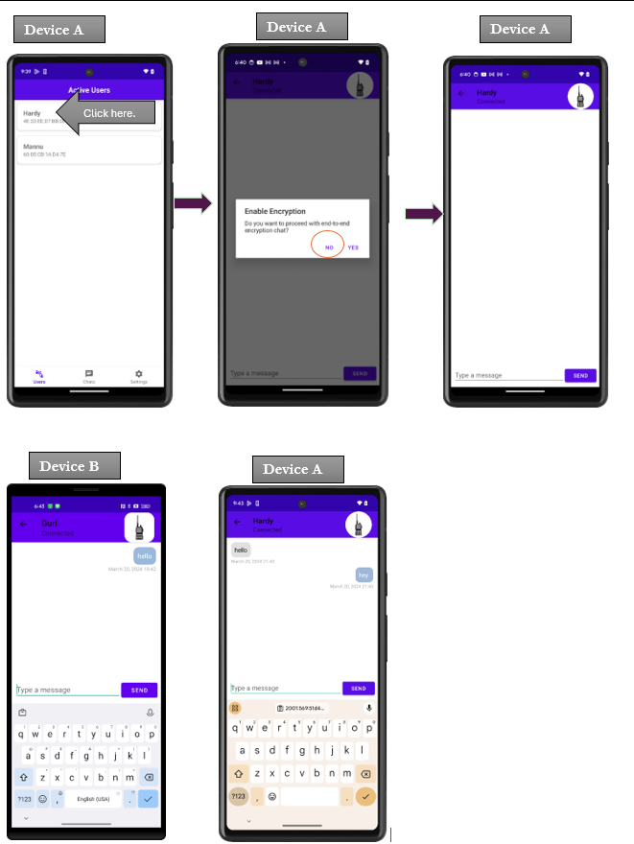

#### Send Messages (Enable Encryption)

* **Objective**: Verify that messages can be encrypted and decrypted correctly.
* **Steps**:
  1. Enable encryption from the chat settings.
  2. Send an encrypted message to the connected device.
  3. Check if the message is received and decrypted on the receiving device.
* **Expected Outcome**: The encrypted message is successfully decrypted on the receiving end, maintaining its integrity and confidentiality.
* **Result**:

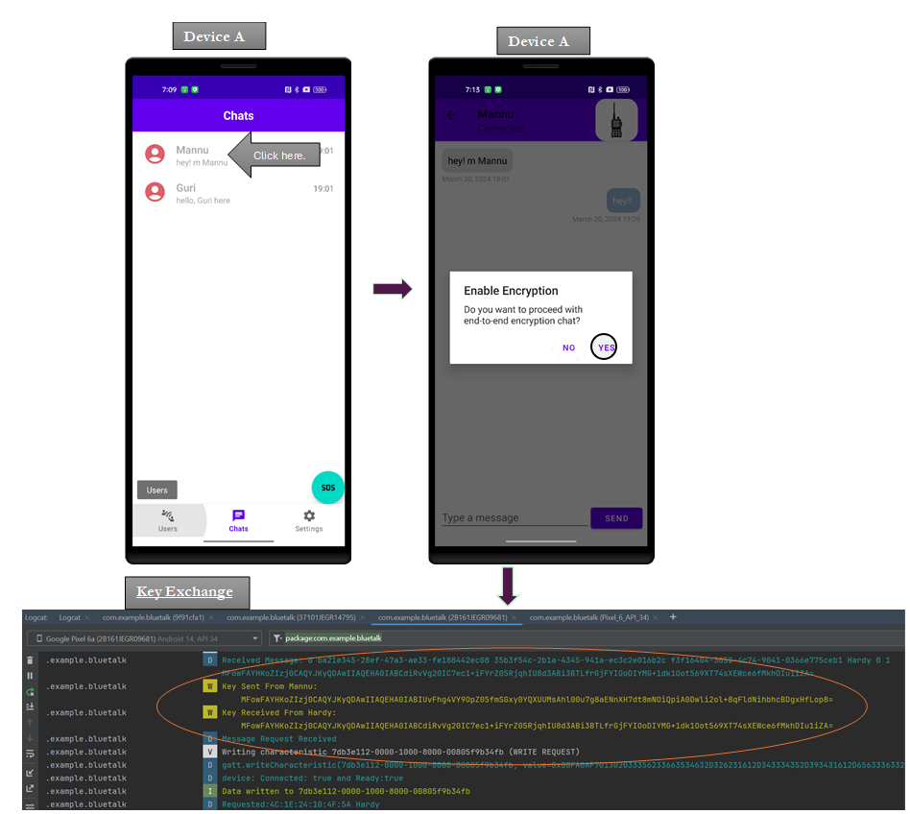







#### Using Walkie Talkie

* **Objective**: Test the real-time voice communication feature.
* **Steps**:
  1. Access the Walkie-Talkie feature within a chat.
  2. Hold down the push-to-talk button, speak a message, and release.
  3. Check if the voice message is received and playable on the connected device.
* **Expected Outcome**: The voice message is transmitted clearly and is understandable on the receiving device.
* **Test Results**:





Device B received audio.

#### Sending SOS

* **Objective**: Ensure the SOS feature broadcasts an emergency signal to nearby devices.
* **Steps**:
  1. Navigate to the SOS feature within the app.
  2. Activate the SOS signal.
  3. Check for receipt of the SOS alert on nearby devices.
* **Expected Outcome**: The SOS alert is received by all nearby devices, indicating the sender’s need for assistance.
* **Result:**



SOS Received on Both Devices

#### Connecting through Proxy

#### 

##### Connecting Through Proxy When the Other Device is Out of Range from the Beginning.

1. **Objective**: Test the app's ability to automatically utilize a proxy device for communication when the recipient device is out of range from the beginning.
2. **Steps**:
3. **Initial Setup**: Ensure Device B (recipient) is out of the direct range of Device A (sender).
4. **Proxy Identification**: Position Device C (proxy) within Bluetooth range of both Device A and Device B, acting as a potential relay point.
5. **Initiate Communication**: From Device A, attempt to send a message to Device B.
6. **Proxy Engagement**: Observe if Device A automatically identifies and uses Device C as a proxy to relay the message to Device B.
7. **Message Delivery Confirmation**: Verify that Device B receives the message via Device C.
8. **Expected Outcome**: Despite the initial distance, Device A successfully communicates with Device B through Device C, illustrating the proxy mechanism's effectiveness from the start.

##### With Encryption:

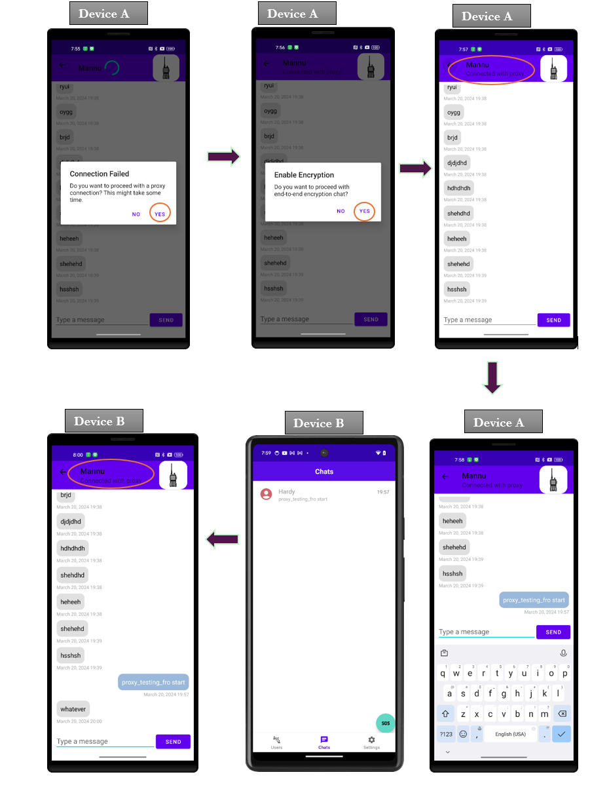



##### Without Encryption:

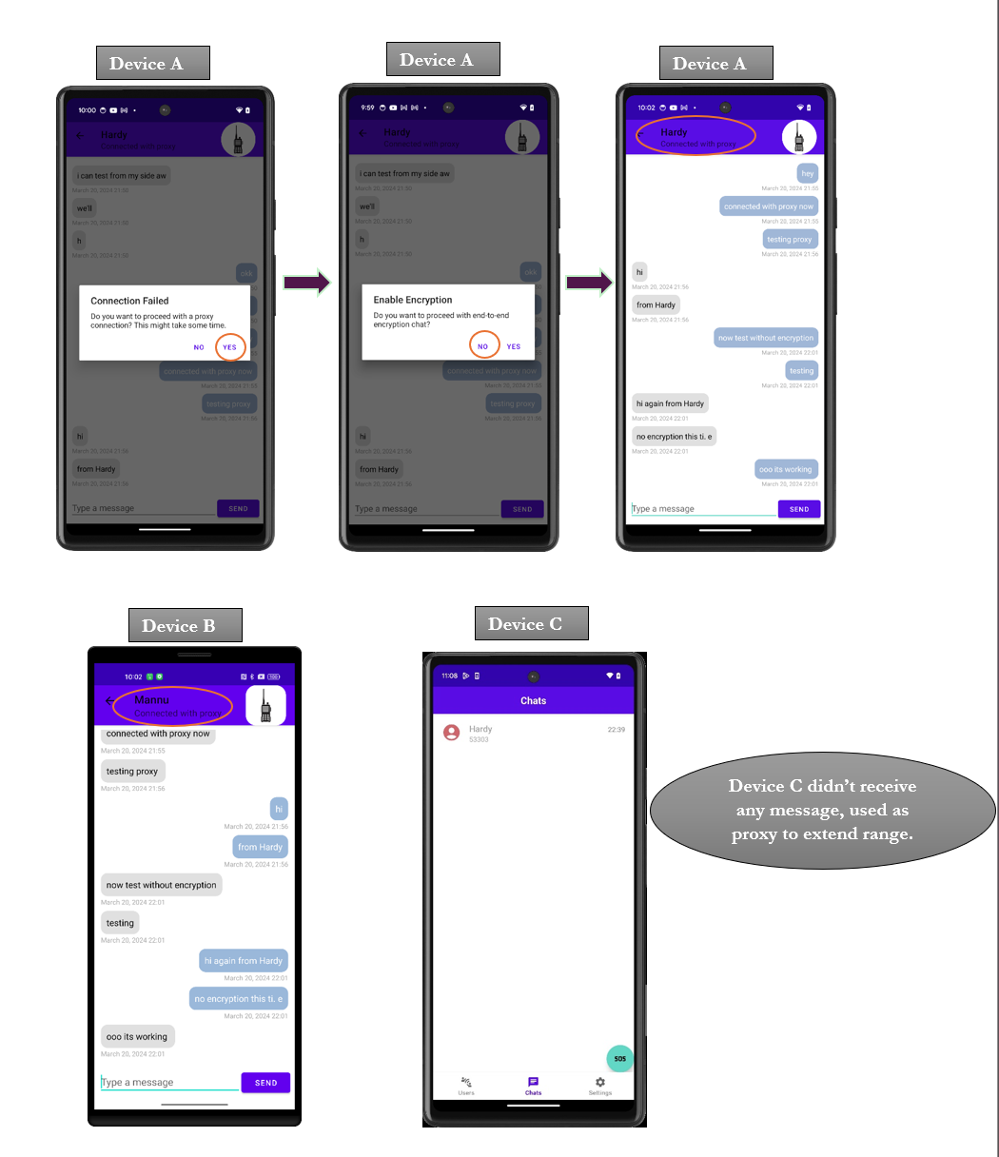

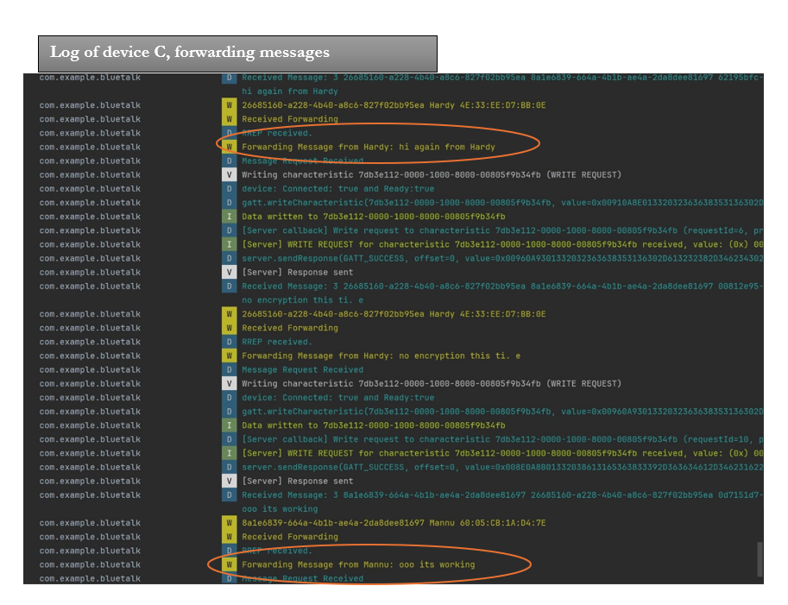

##### Connect Through Proxy After Direct Connection Loss

* **Objective**: Evaluate the app's capability to dynamically switch to using a proxy device for communication following a loss of direct connection.
* **Steps**:
* **Establish Direct Connection**: Connect Device A and Device B directly within Bluetooth range.
* **Simulate Connection Loss**: Move Device B out of the direct range, simulating a disconnection.
* **Proxy Activation**: With Device C within the range of Device A, check if the app automatically transitions to using Device C as a proxy to Device B.
* **Continued Communication**: Attempt to resume messaging from Device A to Device B through Device C.
* **Verify Successful Relay**: Ensure that messages are relayed to Device B through Device C post-disconnection.
* **Expected Outcome**: The app adeptly transitions to proxy-based communication upon direct connection loss, maintaining uninterrupted messaging capability.

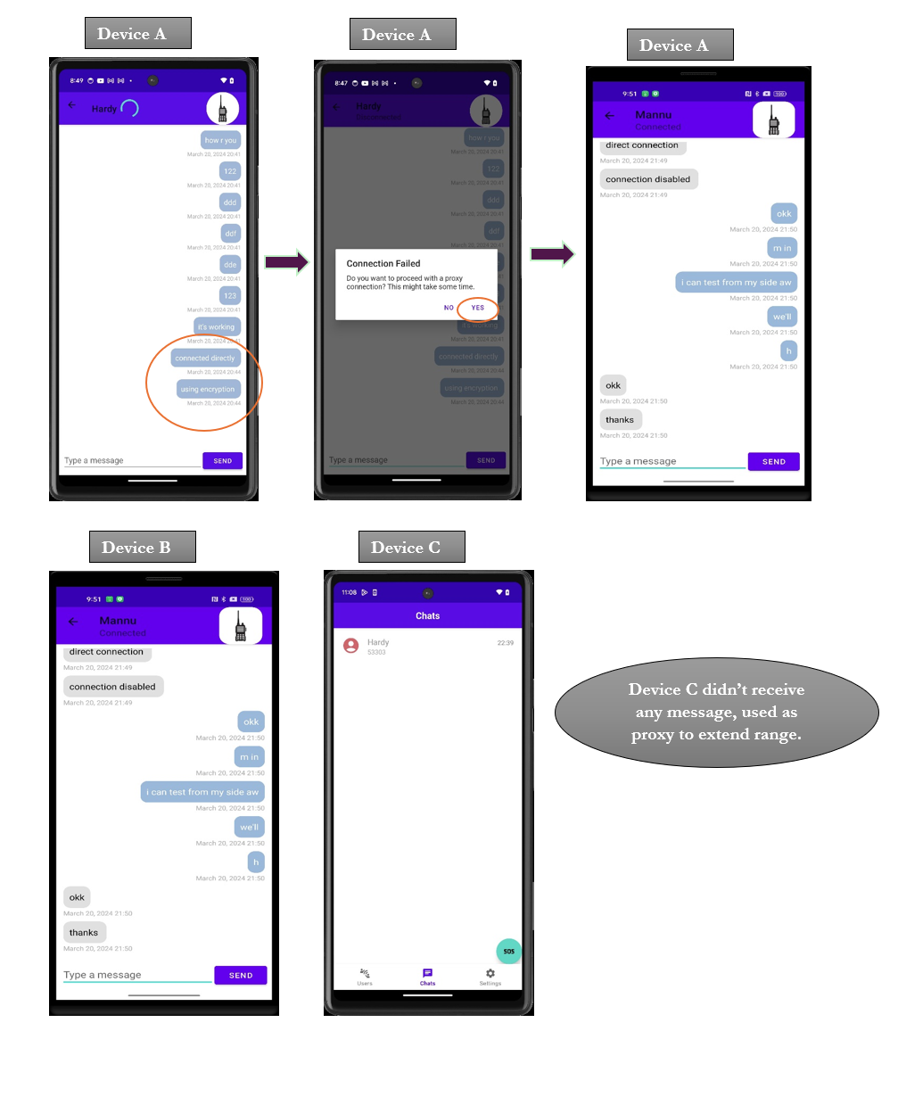

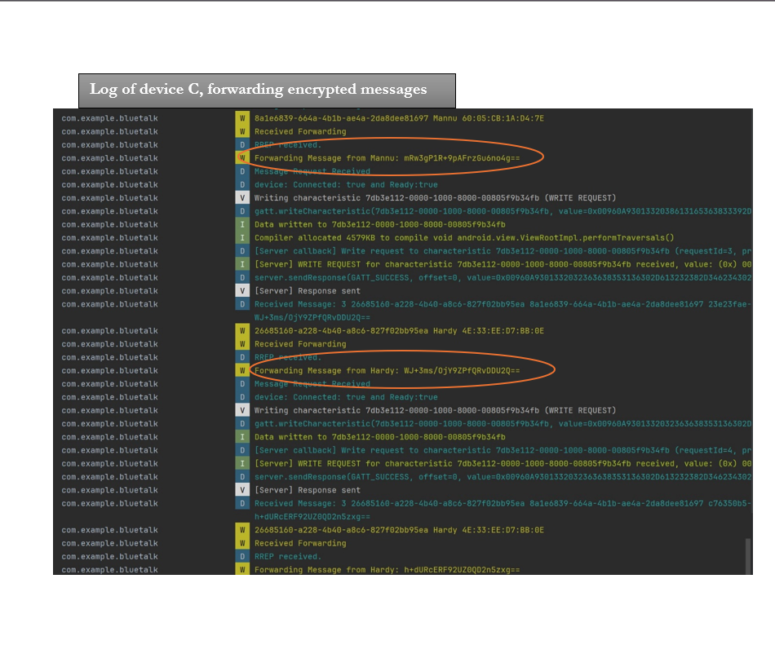

#### Trying to use the Walkie-Talkie feature while disconnected.

* **Objective**: Evaluate the app's behavior when attempting to use the Walkie-Talkie feature without an active Bluetooth connection.
* **Steps**:

1. Ensure no active Bluetooth connections exist between your device and others.
2. Navigate to the Walkie-Talkie feature within the app.
3. Attempt to send a voice message using the Walkie-Talkie functionality.

* **Expected Outcome**: The app should prevent the action by not showing the Walkie-Talkie UI.
* **Test Results**:

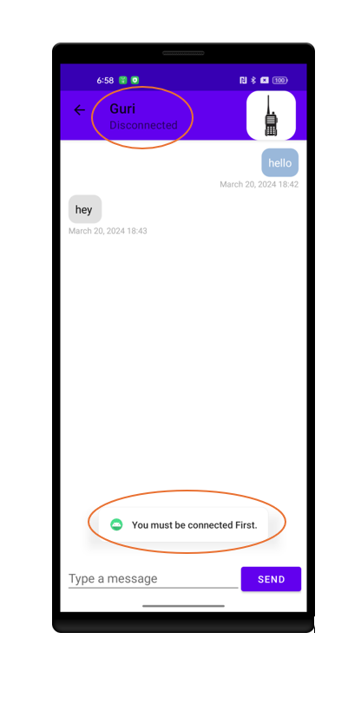

#### Sending messages from two devices to one

* **Objective**: Test the app's capability to handle concurrent incoming messages from two different devices to a single recipient.
* **Steps**:
* Establish connections from Device A and Device B to Device C (the recipient).
* Simultaneously send different messages from Device A and Device B to Device C.
* Observe and document the order of message receipt and any potential delays or issues in Device C receiving both messages.
* **Expected Outcome**: Device C should receive both messages successfully, managing them without loss or significant delay, showcasing the app's ability to handle multiple concurrent incoming messages.
* **Result**:

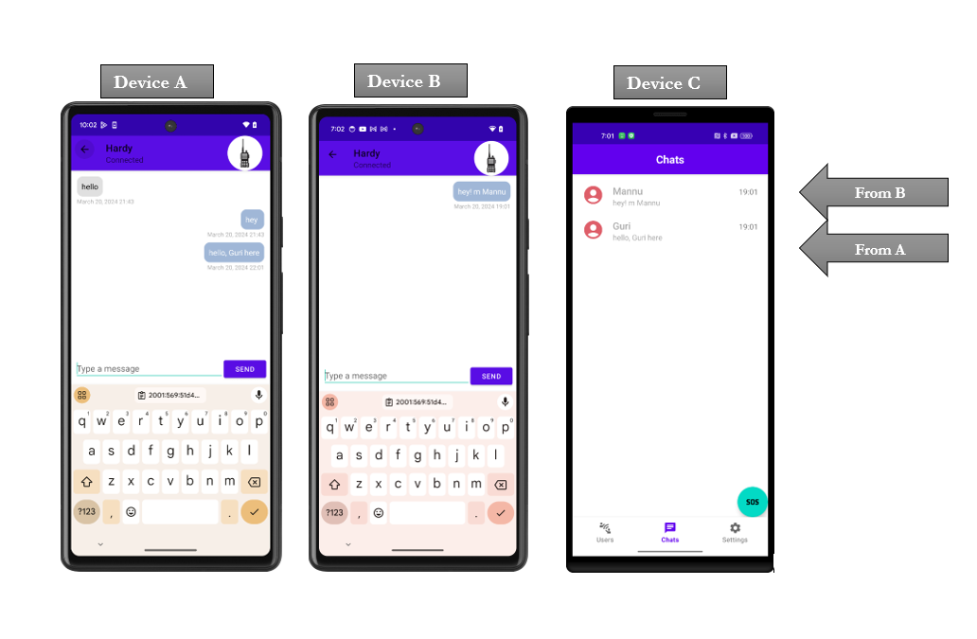

#### Sending a message to the disconnected user

* **Objective**: Assess the app's capability to handle attempts to send messages to a user who has become disconnected or is out of Bluetooth range.
* **Steps**:

1. **Establish Connection**: Initially, establish a direct Bluetooth connection between two devices, Device A (sender) and Device B (receiver).
2. **Simulate Disconnection**: Simulate a scenario where Device B either moves out of range or becomes disconnected from Device A for any reason (e.g., Bluetooth turned off on Device B).
3. **Attempt Message Send**: From Device A, attempt to send a message to the now-disconnected Device B.

* **Expected Outcome**: The app should manage the situation by notifying the sender of the disconnection and should not send the message.
* **Result**:   
    
  

#### Retaining Chats Post-App Closure

* **Objective**: To verify that the app preserves chat history and user messages after the app is closed and reopened, ensuring that users can continue conversations without loss of data.
* **Steps**:

1. **Active Chatting**: Engage in active chat sessions between two or more devices (e.g., Device A and Device B), exchanging a variety of messages.
2. **Close the App**: On both devices, fully close the "Blue Talkie" app. This can involve removing the app from the recent applications list or forcing the app to stop through the device's settings menu.
3. **Reopen the App**: After a brief period, reopen the "Blue Talkie" app on both devices.
4. **Verify Chat Retention**: Navigate to the chat history or messages section to check if the conversations held before app closure are still present and intact.
5. **Continue Conversation**: Attempt to continue the conversation from where it left off, sending new messages to ensure that the app not only retains past chats but also seamlessly continues messaging functionality post-reopening.

* **Expected Outcome**: Upon reopening the "Blue Talkie" app, all previous conversations are fully retained and displayed correctly in the chat history. Users should be able to resume conversations without any issues, indicating that the app successfully preserves chat data across sessions.

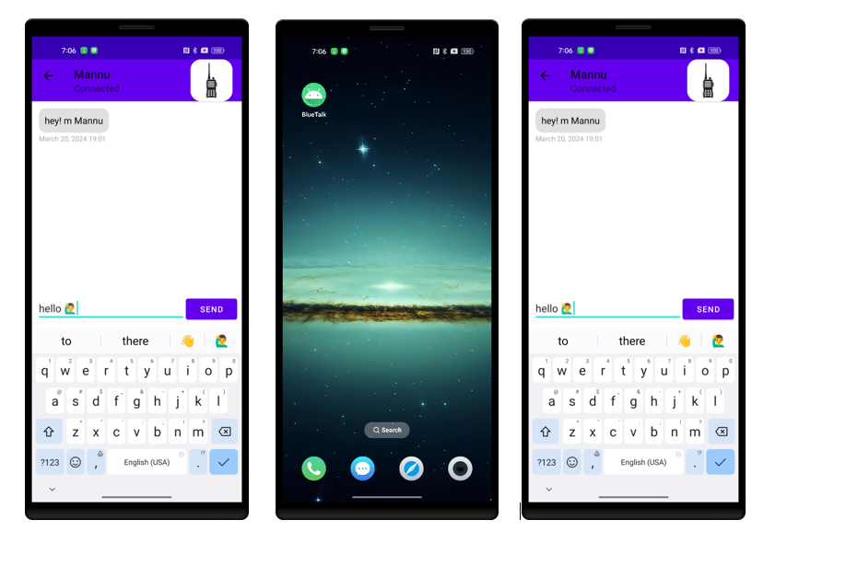

#### Stress Testing

**Objective**: To determine the app's performance limits by simulating high traffic conditions, specifically by sending a large volume of messages in a short period and observing how the app manages under such stress.

**Preparation**:

1. **Devices Setup**: Utilize a minimum of three devices with "Blue Talkie" installed and configured to connect to each other. Designate Device A and Device B as senders and Device C as the receiver.
2. **Test Execution**:

* **High-Traffic Simulation**: Begin sending messages from Device A and Device B to Device C at a high frequency. Automate this process to ensure consistency. The messages should be varied, including regular messages and encrypted messages.
* **Continuous Monitoring**: Throughout the test duration, monitor and record the app's performance on Device C, paying close attention to:
  + **Responsiveness**: Observe if the app remains responsive or exhibits any lag.
  + **Message Delivery**: Note the delivery success rate of all messages and any noticeable delays.
  + **App Stability**: Monitor for any occurrences of the app crashing or displaying errors.
  + **Resource Consumption**: Track the app's impact on the device's resources, noting any significant resource usage spikes.

**Expected Outcome**:

1. "Blue Talkie" should handle the increased message traffic without significant drops in performance or user experience. Although delays in message delivery may occur during peak traffic, all messages should reach Device C.
2. The app is expected to remain stable without crashing or generating errors due to the stress conditions.
3. An increase in resource consumption is anticipated but should not reach levels that severely affect the device's overall performance.

##### With Encryption

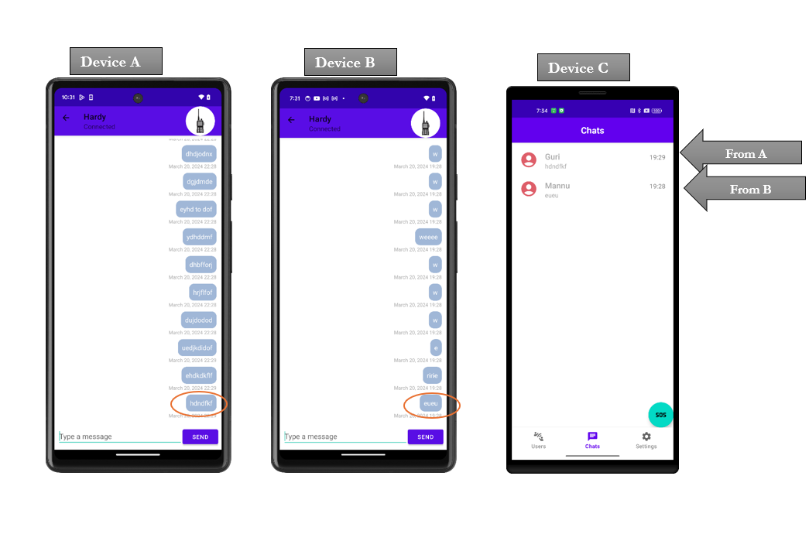

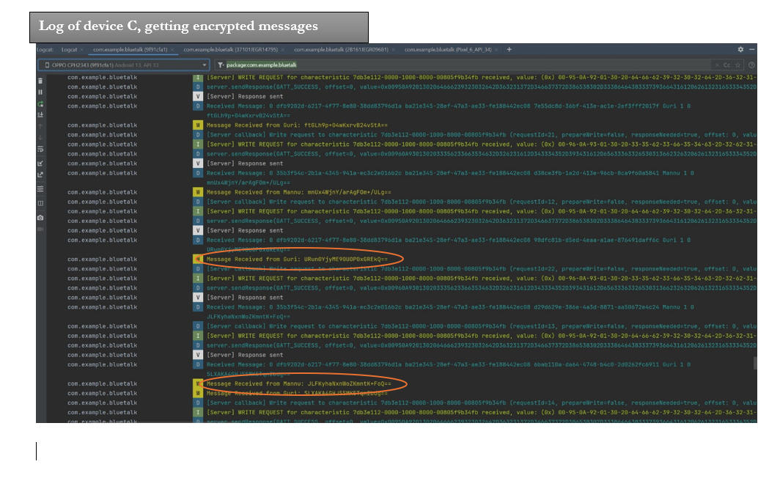

##### Without Encryption

Same test was performed using encryption. Log from device C are shown below.

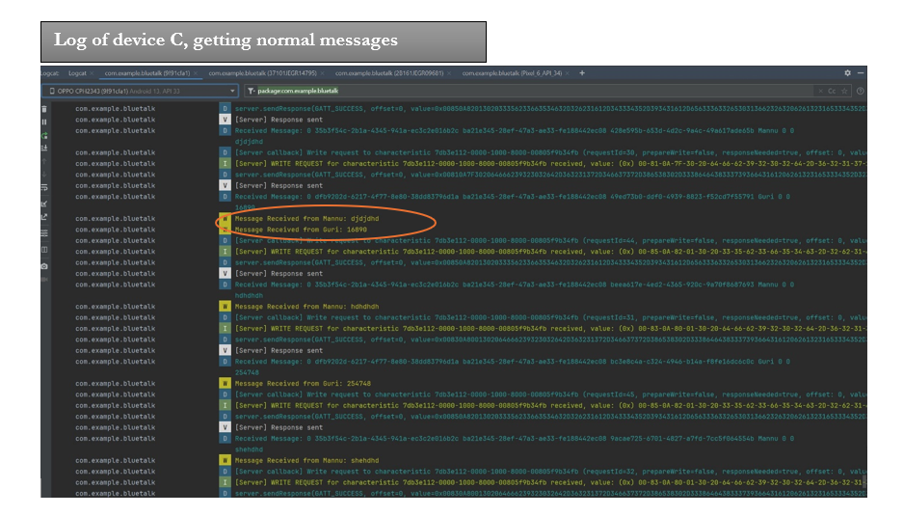

## Implications of Implementation

The development journey of "Blue Talkie" has been both challenging and enlightening, uncovering the inherent limitations of Bluetooth Low Energy (BLE) technology while also showcasing the app's innovative solutions for offline communication. This section delves into the practical implications of these limitations on the app's performance and functionality, alongside the strategic measures implemented to mitigate their impact.

### BLE Constraints and Challenges

**GATT 133 Errors**

One of the notable challenges encountered during the implementation of "Blue Talkie" is the BLE's limitations, particularly the infamous GATT 133 error. This error leads to disconnections that are often unpredictable and undocumented in terms of root causes. The GATT 133 error exemplifies the complexities of working with BLE, highlighting the difficulty in ensuring consistent connection stability. Efforts to mitigate this issue involved implementing robust error handling and reconnection strategies, yet the underlying unpredictability of BLE connections remains a challenge.

**Connection Establishment Time**

The establishment of BLE connections, requiring up to 2-3 seconds, is another limitation impacting user experience. This delay is attributed to the necessary operations BLE must perform, such as service discovery and MTU size requests. To enhance user perception of connection speeds, "Blue Talkie" employs visual feedback and background processes to manage these operations, minimizing the apparent latency and keeping the user informed of the connection progress.

**Connection Reliability**

Further complicating the BLE usage is the occasional sticking of connections at certain operations, rendering the connection unresponsive. This issue can lead to messages not being delivered as expected, affecting the reliability of the app's communication features. To address this, "Blue Talkie" includes mechanisms to detect and resolve stuck connections, such as timeouts and retry logic. However, these solutions cannot entirely eliminate the possibility of such occurrences, underscoring the inherent challenges of BLE communication.

**Performance and Functionality**

Despite these challenges, "Blue Talkie" demonstrates significant strengths in performance and functionality. The app successfully leverages BLE technology to facilitate offline communication, including text messaging, voice communication via the Walkie-Talkie feature, and emergency SOS signals. The proxy feature, designed to extend the communication range beyond direct BLE limits, showcases the app's innovative approach to overcoming BLE range constraints.

### Managing Sequential BLE Operations and Implementing a Queue System

A pivotal aspect of "Blue Talkie's" functionality hinges on its ability to reliably manage BLE operations, which inherently process every request sequentially. Attempting simultaneous write operations can lead to a bottleneck, significantly increasing the likelihood of subsequent operations failing, often indicated by a **GATT_BUSY** error. This affects not only the reliability of the connection but also the overall user experience, as messages and commands could be delayed or lost.

#### Overcoming Sequential Operation Limitations

To effectively overcome the challenges posed by BLE's sequential processing, "Blue Talkie" implements a sophisticated queue system. This system ensures that all BLE operations, particularly write requests, are enqueued and executed in a controlled, sequential order. Here's how it benefits the app:

* **Reduces Operation Failures**: By queuing operations and processing them one at a time, "Blue Talkie" minimizes the chances of encountering **GATT_BUSY** errors, leading to a more stable and reliable BLE connection.
* **Improves Message Delivery**: The queue system ensures that messages are sent in the order they are initiated, preserving the sequence of communication, which is crucial for user conversations.
* **Enhances Robustness**: This approach provides a buffer against the unpredictability of BLE behavior, making the app more resilient to underlying technology limitations.

**Implications for User Experience**

The integration of a queue system for managing BLE operations significantly enhances "Blue Talkie's" performance and reliability. It addresses a critical aspect of working with BLE technology, turning a potential limitation into a strength. Users benefit from smoother, more reliable communication, even when BLE connections are traditionally challenged.

## Innovation

"Blue Talkie" stands at the intersection of technological innovation and real-world utility. Traditional offline communication tools have been mainly anchored by their inherent limitations. The critical innovation of "Blue Talkie" is not just the integration of existing technologies but the reimagining of how they can be harmonized to create an extensive and efficient communication system. For instance, the Extended Coverage through Proxies challenges the long-held belief regarding Bluetooth's limited range. Instead of seeing Bluetooth's range as a restriction, "Blue Talkie" leverages it, using intermediary devices to relay and extend communication reach. This inventive proxy system amplifies the communication sphere and establishes a resilient network. In essence, this approach goes beyond mere iterative improvement of existing methods; it represents a paradigm shift in how we perceive and utilize offline communication tools.

Furthermore, integrating the Walkie-Talkie feature is a technical addition and thoughtful incorporation of real-time voice messaging. This harmoniously converges the immediacy of voice communication with the persistence of text-based chats. Moreover, in an era where breaches in data privacy make headlines, "Blue Talkie" ensures uncompromised security with end-to-end encryption. This encapsulates every data byte, offering a shielded corridor for offline communication. Additionally, the emergency SOS signal functionality symbolizes the application’s commitment to societal welfare, presenting users with a beacon in times of distress.

The inclusion of the Walkie-Talkie feature and the emergency SOS signal functionality further underscores the application's commitment to pushing the boundaries of what is possible in offline communication.

## Complexity

"Blue Talkie" embodies a mosaic of technical nuances woven together to achieve its envisioned functionality. One standout challenge is harnessing Dynamic Ad Hoc Networking. Unlike the more predictable terrains of static networks, ad hoc networks constantly evolve. They present a dynamic tapestry, adapting seamlessly to real-time shifts in the device environment. Devices do not merely participate; they actively influence the network's overarching topology and flow. Catering to this spontaneous and ever-shifting nature demands sophisticated algorithms designed to pivot and adapt in tandem with the network's fluidic dance.

End-to-end encryption stands as another pillar of intricacy. The sanctity of a user's communications hangs in the balance, making the seamless and secure encryption of messages non-negotiable. Integrating a robust encryption system within "Blue Talkie" ensures each communication byte remains confidential, shielded from prying eyes. Marrying this security layer with the unpredictable dynamics of an ad hoc network only intensifies the challenge.

Diving deeper into the app's mechanics, Optimized Routing emerges as a key player. It is not merely about transmitting data but about doing so with intelligence and foresight. The application is responsible for charting the most strategic path for its data packets, considering ever-changing variables like device proximity, density, and potential communication bottlenecks.

Furthermore, the issue of battery consumption is of prominence. Bluetooth communication can be demanding on a device's power reserves, especially when sustained. Therefore, crafting "Blue Talkie" to operate power-efficiently without compromising its advanced communication attributes requires a nuanced design approach.

## Research in New Technologies

The development of "Blue Talkie" was not just a journey through the familiar landscapes of software development but also an expedition into the relatively uncharted territories of Bluetooth Low Energy (BLE) technology and its integration within the framework of offline communication applications. This section delves into the technological explorations undertaken, the challenges encountered, the limitations discovered, and the innovations spurred by this project.

### Exploring BLE Technology

The core functionality of "Blue Talkie" is predicated on the efficient use of BLE technology, chosen for its low energy consumption and ubiquity in modern smartphones. The initial phase of development involved a deep dive into BLE's capabilities, understanding its operational paradigms, and exploring how it could be leveraged to facilitate offline messaging and voice communication.

**Learnings**:

* **Sequential Operation Handling**: A significant insight was gained into how BLE process requests sequentially, which underscored the necessity of implementing a queue system for managing write operations, thereby avoiding the **GATT_BUSY** errors.
* **Connection Stability**: The notorious GATT 133 error highlighted the challenges of maintaining stable connections, pushing us to implement robust error handling and reconnection strategies.

### Limitations and Innovations

The exploration of BLE technology was eye-opening, particularly in understanding its inherent limitations and how they could spur innovation within the "Blue Talkie" app.

**Limitations**:

* **Range and Reliability**: BLE's limited range and the occasional unpredictability of connection stability posed significant challenges. These limitations prompted the innovative use of a proxy mechanism to extend the communication range beyond BLE's direct capabilities.
* **Connection Establishment Time**: The inherent delay in establishing BLE connections due to service discovery and MTU size negotiation highlighted the need for optimizing user feedback mechanisms to manage user expectations during these operations.

**Innovations**:

* **Proxy Mechanism**: Developing a proxy feature to facilitate message relay through intermediate devices directly responding to BLE's range limitation, showcasing a creative approach to extending communication capabilities.
* **Queue Management System**: Addressing the sequential processing of BLE operations with a queue system was an innovation born out of the necessity to manage message traffic efficiently, ensuring reliability and user experience.

### Bugs, Challenges, and New Applications

Several bugs and challenges emerged during the development process, providing valuable lessons and opening new avenues for application improvements.

**Bugs and Challenges**:

* Encountering and mitigating the **GATT_BUSY** and GATT 133 errors were among the significant hurdles, pushing us to enhance our understanding of BLE's operational nuances.
* The variability in BLE performance across different devices and manufacturers underscored the need for extensive testing and optimization to ensure a consistent user experience.

**New Applications**:

* The research and development efforts led to identifying potential new applications for "Blue Talkie," including emergency communication systems in remote areas and crowd management solutions in areas with poor internet connectivity.

## Future Enhancements

As "Blue Talkie" continues to evolve, the focus remains on not just meeting but exceeding the expectations of our users by incorporating innovative solutions and improvements. Reflecting on the app's current capabilities and the technological landscape, we envision a series of enhancements aimed at further solidifying the app's position as a leader in offline communication. These future developments are rooted in realism yet ambitious, aiming to push the boundaries of what is currently possible.

### Hybrid Bluetooth System Integration

The most exciting prospect for "Blue Talkie" is the integration of a hybrid Bluetooth system, combining the best aspects of Bluetooth Classic and BLE. This innovative approach aims to:

* **Maximize Efficiency**: Seamlessly switch between Bluetooth Classic and BLE to optimize for higher data transfer rates or lower energy consumption as needed.
* **Enhance Versatility**: Improve the app's ability to handle diverse data types and communication needs, from text messaging to voice communication and file transfers.
* **Boost Connection Stability**: Leverage the strengths of both Bluetooth technologies to offer users a more reliable and consistent communication experience.

### Background Operation Enhancement

Future "Blue Talkie" versions will transform the main BluetalkServer object into a background service. This enhancement will ensure the app can receive messages and notifications even when not actively used, significantly improving usability and ensuring users never miss an important message.

### Connection Reliability and Speed

Dedicated efforts will be made to further enhance the reliability and speed of BLE connections. Through advanced error handling, optimized reconnection strategies, and exploration of new BLE features, we aim to minimize issues like the GATT 133 error and improve the overall user experience.

### User Interface and Experience

The user interface and experience are planned for continuous refinement, with a focus on making "Blue Talkie" more intuitive and engaging. Feedback from user studies will guide enhancements in navigation, accessibility, and customization options, making the app more adaptable to individual user preferences.

### Cross-Platform Compatibility

I plan to extend "Blue Talkie's" reach by developing versions for other platforms, notably iOS. This cross-platform compatibility will enable seamless communication between different device types, broadening the app's user base.

## Timeline and Milestones

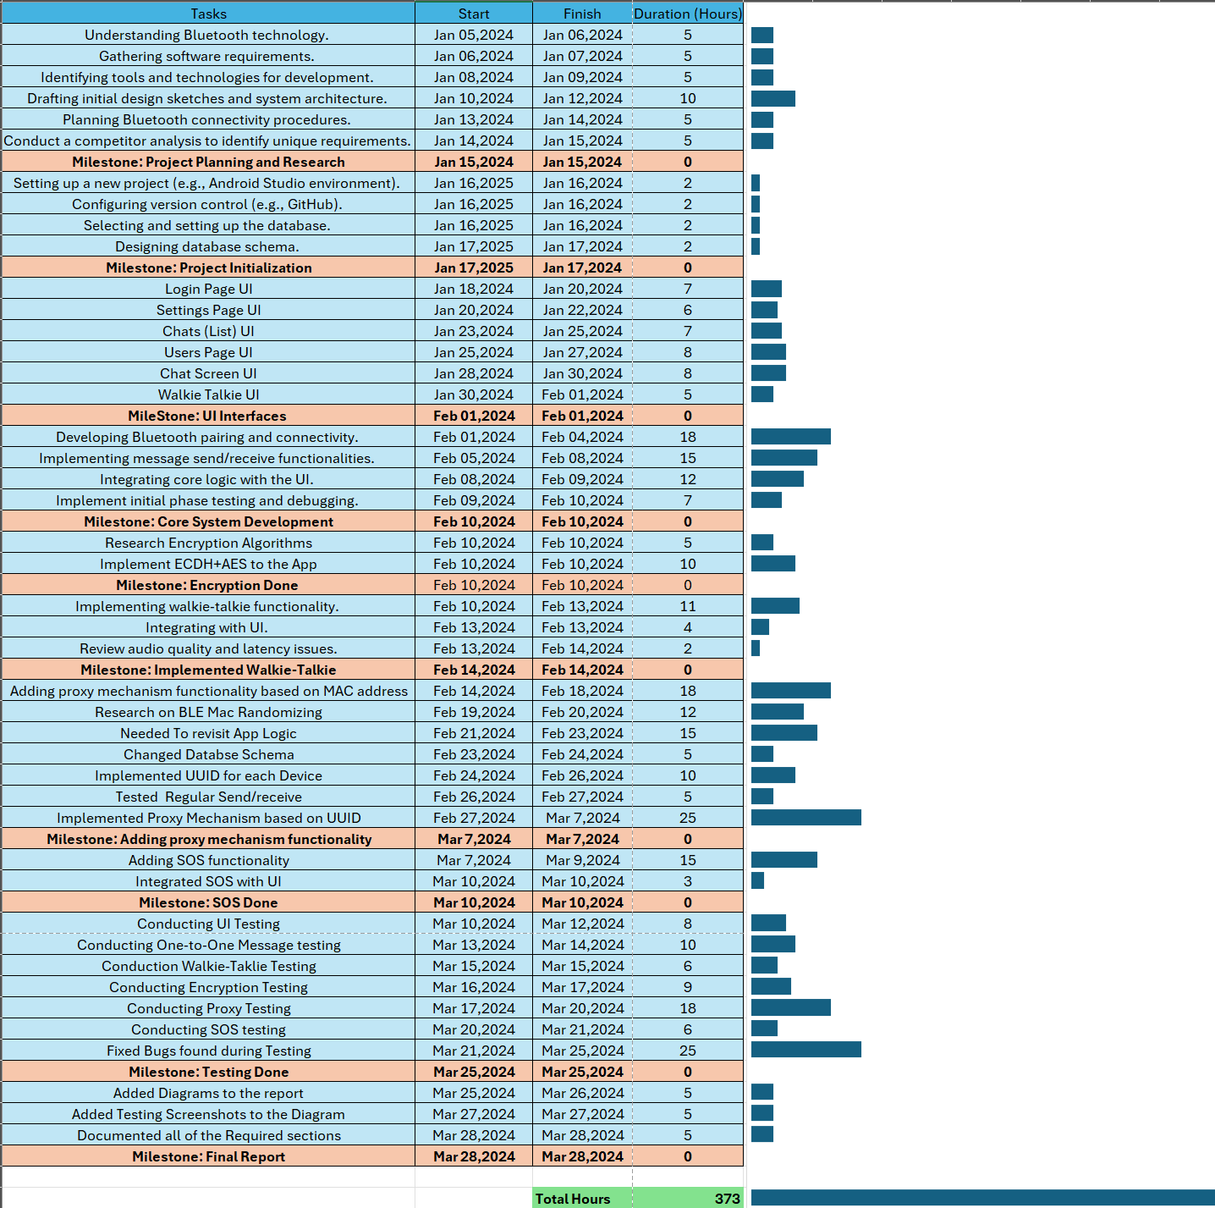

# Conclusion

The journey through the development of "Blue Talkie" has significantly enhanced my expertise in the field of mobile application development, with a particular focus on Bluetooth technology and secure communication protocols. This project transcended the traditional boundaries of classroom learning, presenting real-world challenges and opportunities for innovation that are critical to my specialization in mobile and networked applications.

## Lessons Learned

Throughout the development of "Blue Talkie," I gained insights and knowledge that extended far beyond the curriculum of standard coursework. Key lessons include:

* **The Practical Application of BLE Technology**: Navigating the complexities of BLE for offline communication deepened my understanding of its capabilities and limitations, an area not fully explored in my formal education.
* **Innovative Problem Solving**: The challenges encountered, such as addressing BLE’s GATT 133 error and implementing a queue system for sequential operations, taught me the importance of creative and adaptive problem-solving in software development.
* **Security in Communication**: Implementing ECDH for key exchange and AES for encryption emphasized the critical role of security in app development, underscoring the need to protect user data even in offline scenarios.
* **The Value of User-Centric Design**: The project reinforced the importance of designing with the user in mind, ensuring that the app meets functional requirements and provides a seamless and intuitive user experience.

## Closing Remarks

In conclusion, "Blue Talkie" stands as a testament to the power of combining theoretical knowledge with practical application. The project challenged me to apply what I had learned in a real-world context and pushed me to explore new technologies and develop solutions to unforeseen problems. It has been a pivotal experience in my academic and professional development, providing a solid foundation for my future endeavors in mobile application development.

# Appendix

## Approved Proposal

Attached in the same email.

## Project Supervisor Approvals

N/A

# References

* 1. Android Developers:
     + <https://developer.android.com/develop/connectivity/bluetooth/ble/ble-overview>
  2. BLE Android Guide by InterSog:
     + <https://intersog.com/blog/ble-programming-on-android/#:~:text=BLE%20Programming%20on%20Android%3A%20the%20Complete%20Tutorial%20for,Enable%20notifications%20Subscribe%20for%20data%20change%20notifications%20>
  3. BLE Android Guide by PunchThrough:
     + [The Ultimate Guide to Android Bluetooth Low Energy | Punch Through](https://punchthrough.com/android-ble-guide/)
  4. Nordic BLE Documentation:
     + <https://infocenter.nordicsemi.com/index.jsp?topic=%2Fcom.nordic.infocenter.sdk5.v15.0.0%2Fgeneral_libraries.html>

# Change Logs

N/A